16121148: T7214-12CNG50 LOCATION DIAGRAM

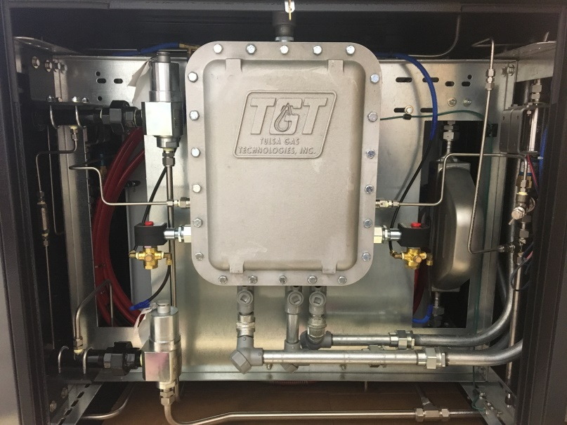
5
13
4
13
4
14
Figure 1: Front
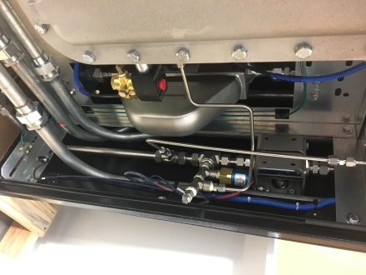
10
11
12
6
Figure 2: Front Right (Typ Back Right)

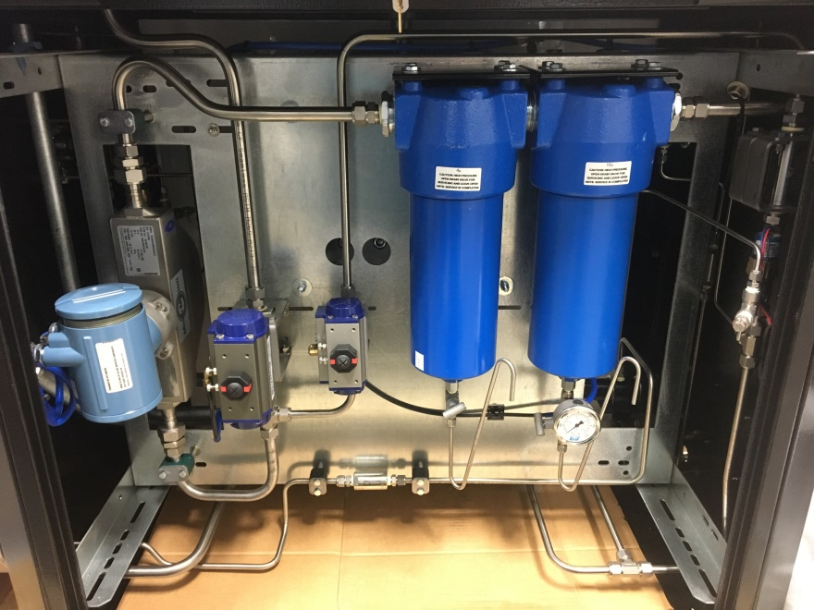
9
9
8
8
6
1
2
7
6
Figure 3: Back

COMPONENTS
ITEM | QTY | DESCRIPTION
1 | 1 | Filter, Parker J6NH-10CWC23-130B
2 | 1 | Filter, Parker J6NX-4C2C23-130B
3 | 1 | Ball Valve, Oasis BV706 / Actuator, Bi-Torq
4 | 2 | Relief Valve, Mercer Series 91
5 | 1 | Meter, Micro-Motion CNG50
6 | 1 | Ball Valve, Oasis BV704
7 | 1 | Ball Valve, Oasis BV706
8 | 3 | Gauge, TGT 5000PSI
9 | 2 | Needle Valve, NoShok
10 | 2 | Bleed Valve
11 | 2 | Pressure Transducer
12 | 2 | Pressure Switch
13 | 2 | Asco Redhat Solenoid Valve,
14 | 1 | Explosion Proof Box, TGT

