16121138-16121146 : T7104-12CNG50 LOCATION DIAGRAM

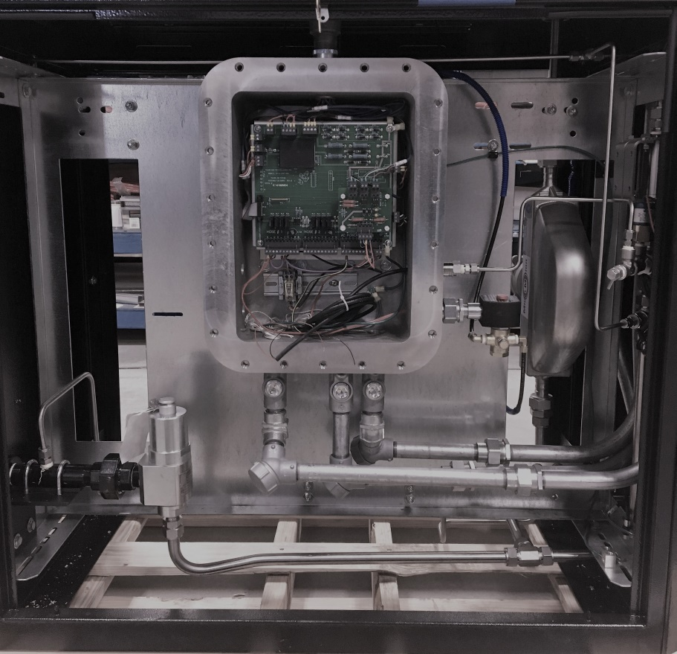
12
13
5
4
Figure 1: Front
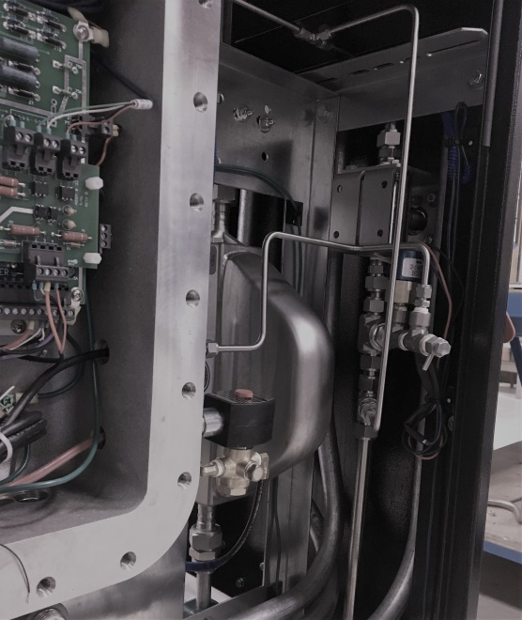
9
10
11
6
Figure 2: Front Right

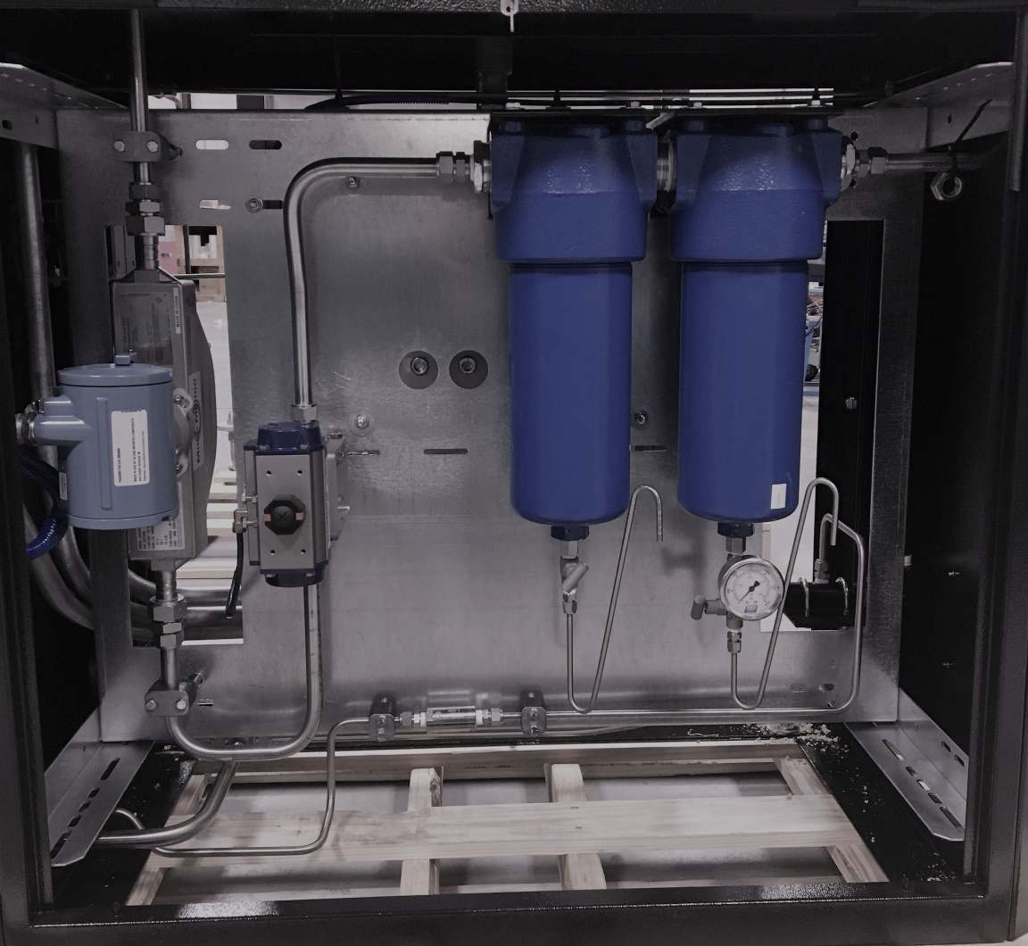
8
8
5
7
3
1
2
Figure 3: Back

COMPONENTS
ITEM | QTY | DESCRIPTION
1 | 1 | Filter, Parker J6NH-10CWC23-130B
2 | 1 | Filter, Parker J6NX-4C2C23-130B
3 | 1 | Ball Valve, Oasis BV706 / Actuator, Bi-Torq
4 | 1 | Relief Valve, Mercer Series 91
5 | 1 | Meter, Micro-Motion CNG50
6 | 1 | Ball Valve, Oasis BV706
7 | 3 | Gauge, TGT 5000PSI
8 | 2 | Needle Valve, NoShok
9 | 1 | Bleed Valve,
10 | 1 | Pressure Transducer,
11 | 1 | Pressure Switch,
12 | 1 | Three-Way Valve,
13 | 1 | Explosion Proof Box, TGT

