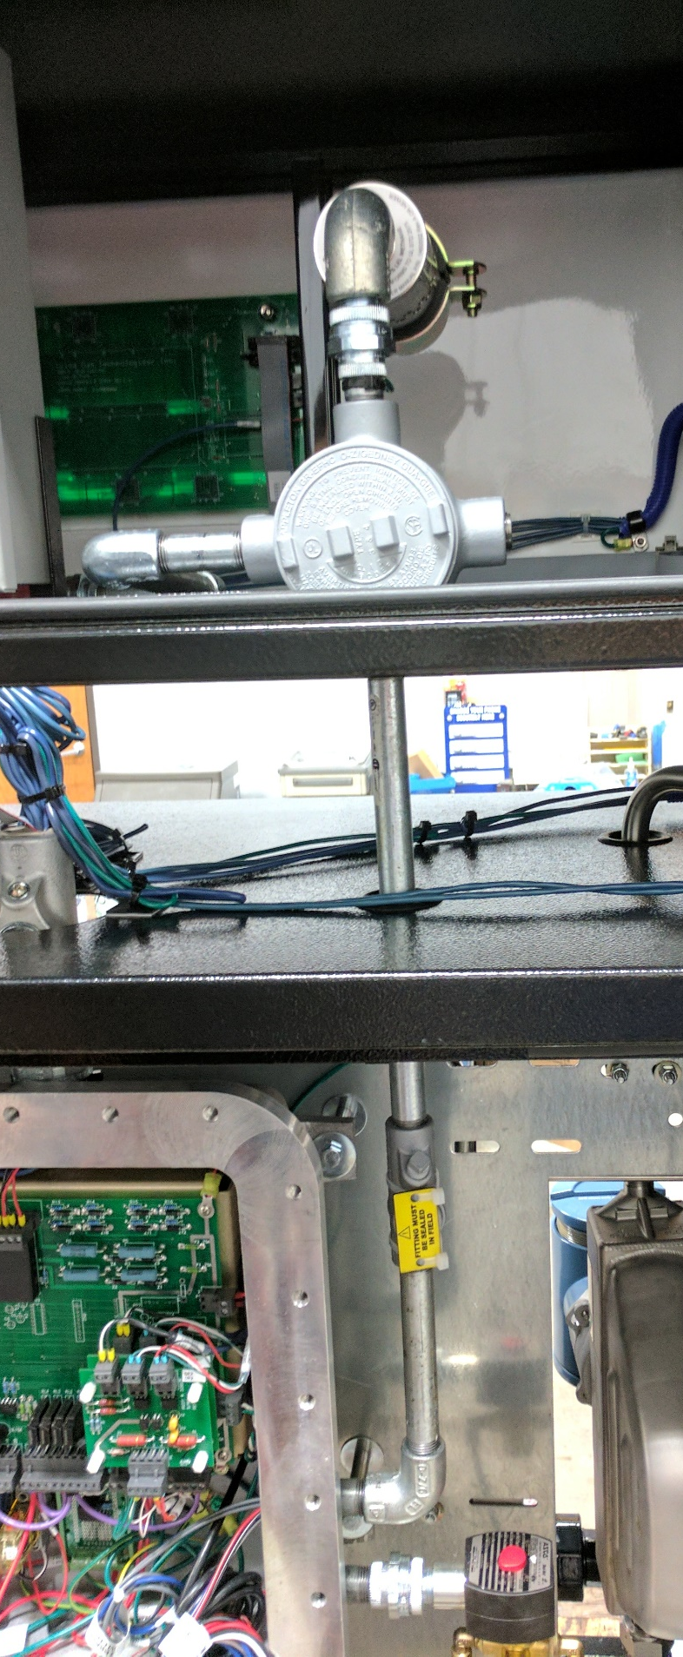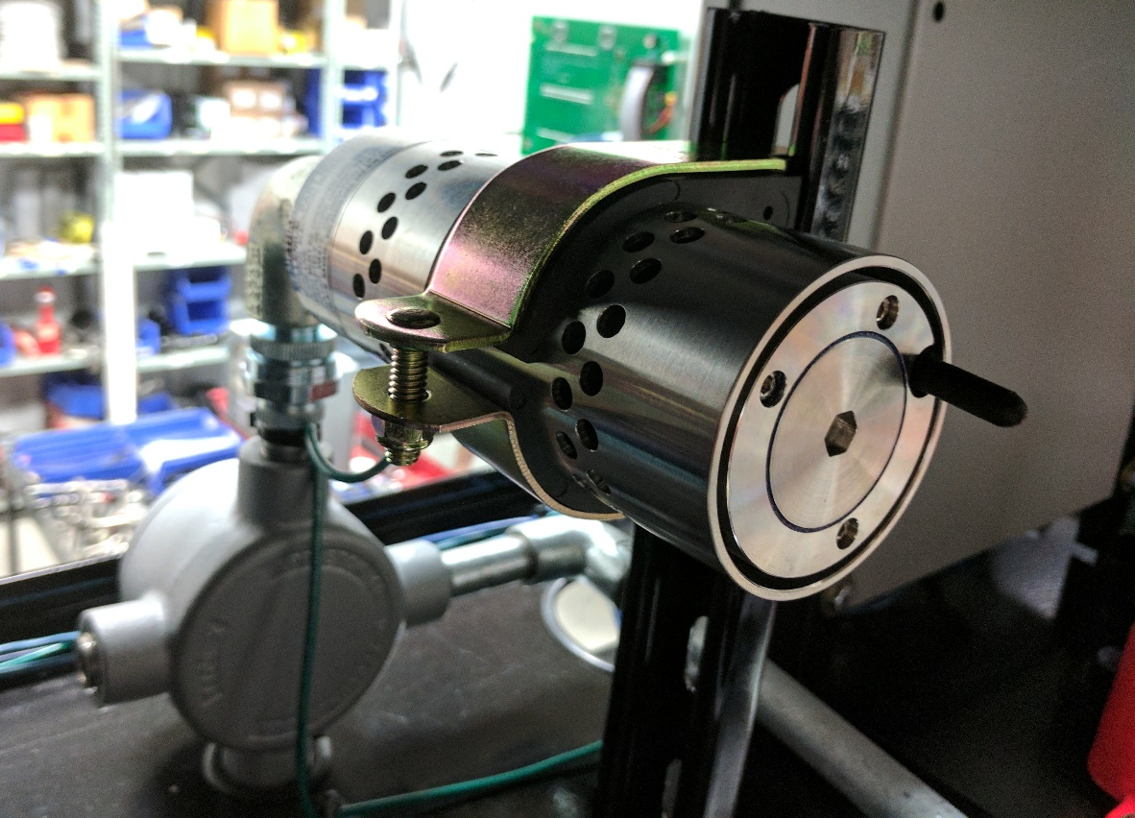
Junction box
Part number: GRX50

par
1/2”to 3/4" reducing bushing

1/2” union
6” nipple ½”
1/2” seal off
1/2” elbow
2-1/2” nipple ½”

12” nipple ½”
1/2” close nipple
3/4” Elbow

Elbow
Soft Clamp part number NIC-25/8
Stainless steel plug
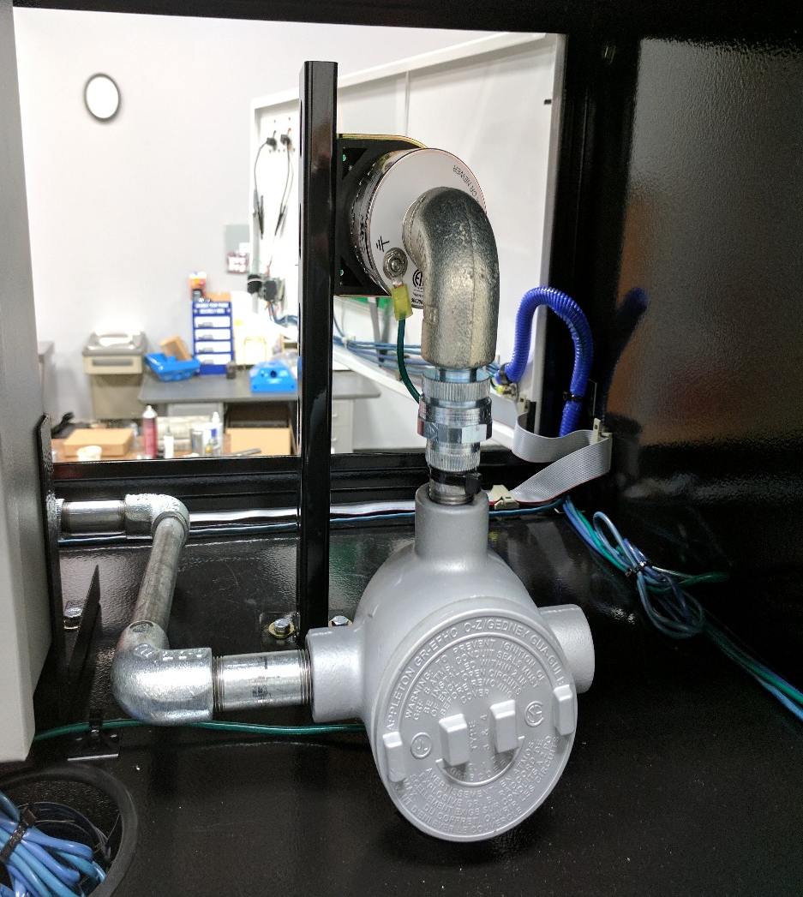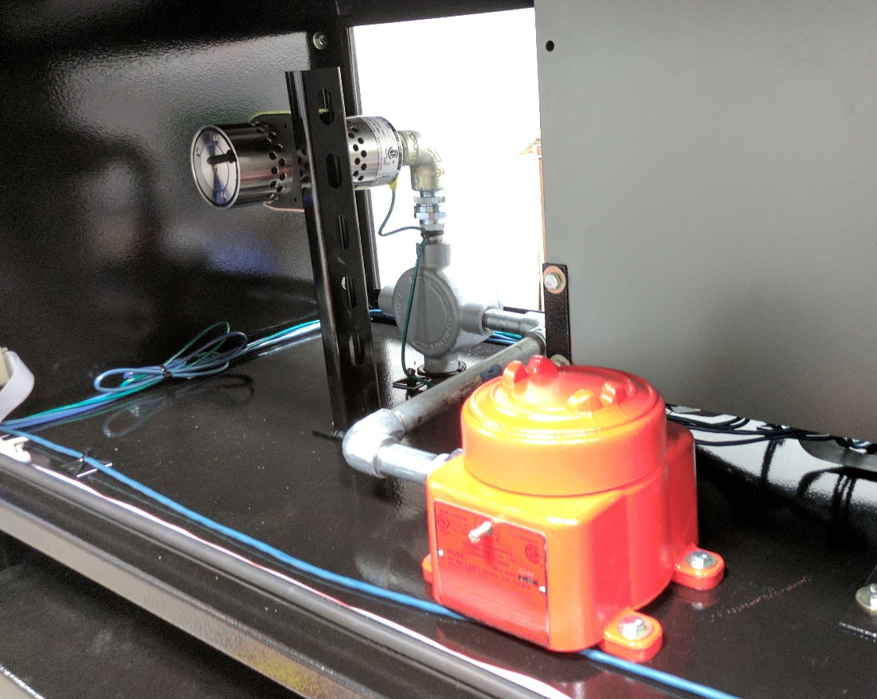
½” Union
3” nipple ½”
½” elbow
8” nipple ½”
1/2" elbow
3” nipple ½”
Parts List

Quantity | Description | Part number or material
1 | 2-1/2” nipple | Galvanized Conduit
3 | 90° Elbow | Galvanized Conduit fitting
1 | 6” nipple | Galvanized Conduit
1 | Seal off | Galvanized Conduit fitting
1 | 12” nipple | Galvanized Conduit
1 | Junction box | GRX50
1 | 1-1/2” nipple | Galvanized Conduit Fitting
3 | ½” union | Galvanized Conduit Fitting
1 | 3/4”-1/2” Reducing Bushing | Galvanized Conduit Fitting
2 | 3” nipple | Galvanized Conduit
1 | 8” Nipple | Galvanized Conduit
1 | ¾” Elbow | Galvanized Conduit Fitting
1 | ½” plug | Stainless Steel Plug
1 | 2-5/8” Soft clamp | NIC-25/8

