17011150: T7204-12CNG50 LOCATION DIAGRAM

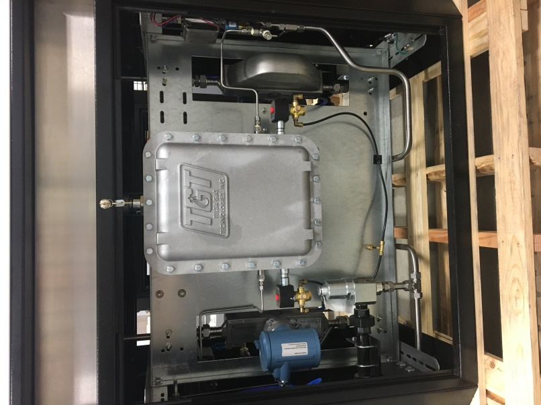
10(x2)
4
3
4
11
Figure 1: Front

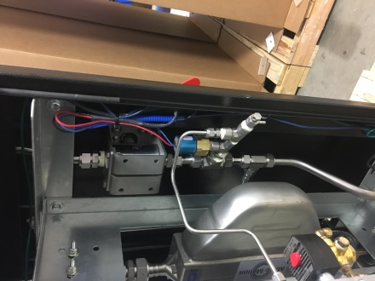
9
7
8
12
Figure 2: Front Right (Typ Back Right)

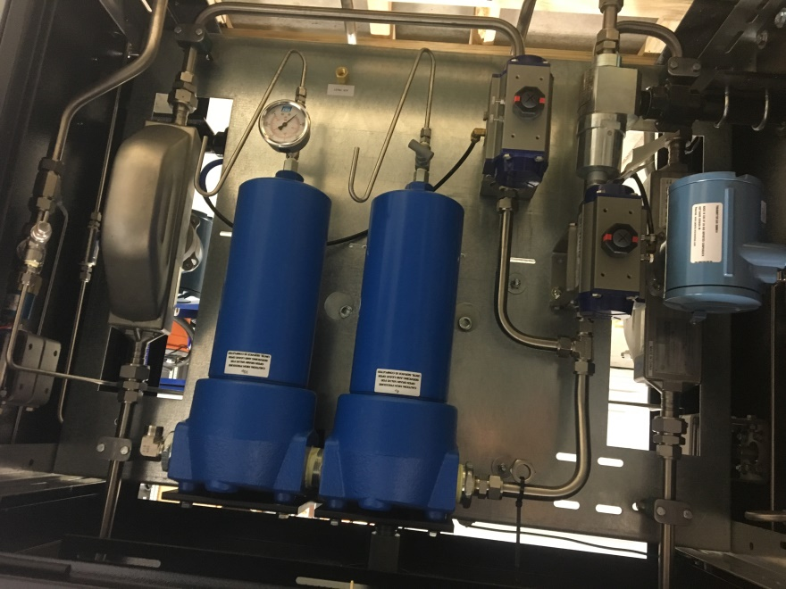
7

5

4 (x2)

2 (x2)

1 (x2)
3

Figure 3: Back

COMPONENTS
ITEM | QTY | DESCRIPTION
1 | 2 | Filter, Parker
2 | 2 | Ball Valve, Oasis
3 | 2 | Relief Valve, Mercer Series 91
4 | 2 | Meter, Micro-Motion CNG50
5 | 3 | Gauge, TGT 5000PSI
6 | 3 | Needle Valve, NoShok
7 | 3 | Bleed Valve
8 | 2 | Pressure Transducer
9 | 2 | Pressure Switch
10 | 2 | Asco Redhat Solenoid Valve,
11 | 1 | Explosion Proof Box, TGT
12 | 2 | Ball Valve, Parker

