TABLE OF CONTENTS
- TYPE OF SYSTEM…………………………………………………………………………………………………………….. 2
- SPECIAL PROVISIONS………………………………………………………………………………………………………. 2
- UNIT MODE……………………………………………………………………………………………………………………. 2
- GENERAL MOTOR CONTROLS…………………………………………………………………………………………. 2
- PLC I/O FORCING……………………………………………………………………………………………………………. 3
- POWER UP AND READY TO START………………………………………………………………………………….. 3
- START SEQUENCE…………………………………………………………………………………………………………… 4
- UNIT RUNNING LOADED…………………………………………………………………………………………………. 4
- CLEARING CYCLE (DRAIN INTERVAL)……………………………………………………………………………….. 4
- STORAGE FILLING SEQUENCE (OPTIONAL PRIORITY PANEL)…………………..………………….……. 4
- STOP SEQUENCE (NORMAL, FAULTED, and ESD)………………………………………………………….…. 6
- DISPENSER VALVE ACTUATION……………………………………………………………………………………..… 8
- TEMPERATURE COMPENSATION………………………………………………………………………………..…… 9
- ALARM AND SHUTDOWN FUNCTIONS………………………………………………………………………..….. 10
- HMI MENUS & CONFIGURABLE PROCESS VARIABLES…………………………………………….……..… 13
  - Main Status……………………………………….………………………………………………….….…….…. 13
  - Alarm Screen………………………………………………………………………………………….……….…. 15
  - Compressor Menu Selection Screen……………………………………………………….…….…… 16
  - Compressor Pressure Alarm and Shutdown Settings…………………………….……….…. 17
  - Compressor Temperature Alarm and Shutdown Settings………………….………….….. 18
  - Compressor Digital and Logical Shutdown Settings………………………….…..…….……. 19
  - Compressor Transducer Settings……………………………………………………………….……… 21
  - Compressor Thermocouple Settings………………………………………………………….……… 22
  - Compressor Oil Heater Settings……………………………………………………………….……….. 23
  - Compressor Sequence Timers……………………………………………………………………………. 24
  - Storage Menu Selection Screen…………………………………………………………………………. 26
  - Storage Pressure Alarm and Shutdown Settings……………………………………………….. 27
  - Storage Transducer Settings……………………………………………………………………………… 28
  - Storage Settings………………………………………………………………………………………………… 29
  - PLC/HMI Main Selection Menu…………………………………..…………………………………….. 31
  - PLC/HMI Network Settings…………………………………………..…………………………………… 32
  - PLC/HMI Email Settings……………………………………………………..……………………………… 33
  - PLC/HMI General Settings………………………………………………….…………………………….. 34
  - PLC/HMI Input IO Flips……………………………………………………….…………….………………. 35
  - PLC/HMI Output IO Forces…………………………………………………………………….………….. 36
- WEB VIEWER ACCESS………………………………………………………………………………………………….…. 37
- PLC IO List……………………………………………………………………………………………………………………… 39
  - OUTPUT IO……………………………………………………………………………………………………….. 39
  - INPUT IO…………………………………………………………………………………………………………… 40
  - ANALOG IO………………………………………………………………………………………………………. 41
- TECHNICIANS NOTES…………………………………………………………………………………………………….. 42

- TYPE OF SYSTEM
  - The PLC is an IDEC FC6A-C40P1CE system performing configuring, monitoring, reporting of shutdown, pressures, and temperatures to a local 8.4” IDEC HG3G Series HMI touch display. All user configurable variables can be entered into the PLC via the local HMI touch display. The panel is powered by a customer supplied 120vac. throughout this sequence the controller is referred to as PLC.
  - The PLC is serving the function of both a unit controller (controlling the compressor package) and a site controller (controlling priority valves and SCADA)
- SPECIAL PROVISIONS
  - The PLC outputs can be forced (latching type function) via the PLC/HMI > OUTPUT I/O FORCES screen. Once the MAINTENANCE MODE is made active any running processes will be sequenced to a NORMAL shutdown state and the unit operating mode will be placed into a MANUAL state. The MAINTENANCE MODE will automatically be disabled when the timer runs out or by pressing the MAINTENANCE MODE “OFF” button on the HMI. While in this mode NO automatic sequencing of the PLC will be available and a MAINTENANCE MODE indicator will be visible in the top section of all HMI screens.
  - Password protection exists on all set points
  - The power for all relays is tied into the site ESD loop.
- UNIT MODE
  - MANUAL (HMI based) - The unit is started manually via the local start pushbutton or the HMI start pushbutton while the panel selection switch is in the “RUN” position.
  - AUTO (HMI based) - The unit is started automatically via a call to start from the storage bank while the panel selection switch is in the “RUN” position.
  - OPERATION SELECTION SWITCH
    - RESET Position (momentary) – Used to reset alarms and fault conditions if they have been resolved.
    - OFF Position (maintained) – No action allowed.
    - RUN Position (maintained) – Required position for manual and automatic operation of the unit.
- GENERAL MOTOR CONTROLS
  - The Motor have running input feedbacks (AUX contacts). If the motor is commanded on (when in AUTO sequencing), the relevant motor run fail timer will be started. If the relevant motor running input is not closed before the timer expires, the unit will be shut down on the relevant motor run failure.

- PLC I/O FORCING (MAINTENANCE MODE)
  - While the unit is in a non-ESD shutdown state, waiting for start permissive from the station, or if it is ready to start, the operator has the ability to manually force on all relevant digital outputs via the PLC/HMI SETTINGS > OUTPUT I/O FORCES page on the HMI.
  - When the MAINTENANCE MODE ‘ON’ touch display button is pressed any active running processes will be sequenced to a NORMAL shutdown state and the unit’s operating mode will be placed into a MANUAL state. Once the proper state is in effect and the units panel selection switch is in the RUN position the latch (ON) and unlatch (OFF) touch display buttons for the so labeled I/O become functional
  - When MAINTENANCE MODE is enabled the operator has 10 minutes to manually force the outputs. Additional time can be added by pressing the ADD TIME button located next to the remaining time countdown.
  - MAINTENANCE MODE may be disabled at any time when the MAINTENANCE MODE ‘OFF’ touch display button is pressed or the timer runs out.
  - While MAINTENANCE MODE is enabled ALL unit shut down conditions are in effect with the exception of low pressure alarms and faults for ALL storage banks. Any shutdown will cause MAINTENANCE MODE to become inactive and any active forces will be reset.
- POWER UP AND READY TO START
When the Power ON/OFF switch is turned to the ‘ON’ position the PLC will power up. The PLC will scan all inputs and the local HMI will display any alarms or shut downs that may exist. After the operator has corrected all shutdown conditions the PLC will initiate the currently selected fill mode selection. If the selected mode does not immediately require a unit run command the outputs will be driven to the following states.
- ESD Remote loop = Energized (De-energized on ESD activation)
- Unit Fault Indicator = De-Energized (Energized when in fault condition)
- Unit/Station Healthy Status Indicator = Energized (De-energized when not healthy)
- Main Motor Starter = De-Energized
- Inlet valve actuator = De-Energized (Closed)
- ESD / Flow valve = De-Energized (Closed)
- Drain / Load valve = De-Energized (Open)
- High Bank solenoid valve = De-Energized (Closed)
- Mid Bank solenoid valve = De-Energized (Closed)
- Low Bank solenoid valve = De-Energized (Closed)
- Time-Fill solenoid valve = De-Energized (Closed)

- START SEQUENCE
  - When the PLC is powered up and AUTO mode is selected, the PLC will examine the pressures of the HIGH BANK, MID BANK, LOW BANK, and TIME-FILL. When any of these pressures fall below the user configurable start pressure set point of that bank, the controller will issue a run command to the units.
  - When the PLC is powered up and MANUAL mode is selected, the local HMI start pushbutton or the start pushbutton located on the main panel is pressed then the controller will issue a run command to that unit.
- UNIT RUNNING LOADED
8.1 The HMI will display an indicator of the LOAD VALVE state and the outputs will be driven to the following states:
- Drain/Load valve actuator = Energized (Closed)
- CLEARING CYCLE (DRAIN INTERVAL)
  - When the unit is running loaded the ‘INTERVAL’ timer will start. Once the interval timer expires, the Drain / Load valve output will be De-Energized to open the valve and the ‘DURATION’ timer will start. Once the Duration timer expires, the Drain / Load valve output will be Energized and the Interval timer will re-start.
During the clearing duration the low process pressure shutdowns and alarms will be locked out. When the ‘DURATION’ timer expires the low process pressure shutdowns and alarms will be enabled. This sequence will occur repeatedly when the unit is running.
- STORAGE FILLING SEQUENCE (OPTIONAL PRIORITY PANEL)
  - Once the PLC has issued a run command, the PLC will energize the corresponding solenoid valve to the bank whose pressure is below its start pressure to begin filling the bank.
  - The DEMAND OFFSET set points for high, mid, and low banks should be of value ranging from smallest offset to largest because storage filling is always HIGH BANK first, then the MID BANK, and lastly the LOW BANK. DIRECT-FILL, when enabled, can supersede HIGH BANK when a HOSE IN USE signal is active. TIME-FILL, when enabled, will fill after LOW BANK. This will allow the user to better utilize the storage capacity of each bank.
    - DIRECT-FILL (IF ENABLED): Once the DIRECT-FILL demand has been satisfied, the HIGH BANK valve (solenoid/actuator) is energized (OPEN)
    - HIGH BANK: Once the HIGH BANK demand has been satisfied, the HIGH BANK valve (solenoid/actuator) will remain energized (OPEN) and the MID BANK valve (solenoid/actuator) is energized (OPEN).
    - MID BANK: Once the MID BANK demand has been satisfied, the MID BANK valve (solenoid or actuator) will remain energized (OPEN) and the LOW BANK valve (solenoid or actuator) is energized (OPEN).
    - TIME-FILL (IF ENABLED): Once the LOW BANK demand has been satisfied, the LOW BANK valve (solenoid or actuator) will remain energized (OPEN) and the TIME-FILL valve (solenoid or actuator) is energized (OPEN).
  - Check valves should be installed downstream of the solenoid/actuator valves to prevent the banks from equalizing during the fill process. However, the storage banks will equalize pressures once the low bank is near the temperature compensated stopping pressure.
  - PRIORITIZING
    - When DIRECT-FILL is enabled, HIGH BANK is being filled, a HOSE IN USE signal is active, and the DIRECT-FILL pressure drops below its FINAL TARGET PRESSURE minus its PRIORITY DEADBAND setting, then the HIGH BANK valve (solenoid/actuator) will be de-energized (CLOSED) to allow the compressors to fill the DIRECT-FILL line.
    - When the MID BANK is being filled, if the HIGH BANK pressure drops below its FINAL TARGET PRESSURE minus its PRIORITY DEADBAND setting, then the MID BANK valve (solenoid/actuator) will be de-energized (CLOSED) to allow the compressors to fill HIGH BANK storage.
    - When the LOW BANK is being filled, if HIGH BANK or MID BANK pressures drops below their FINAL TARGET PRESSURE minus their PRIORITY DEADBAND settings, then the LOW BANK valve (solenoid/actuator) will be de-energized (CLOSED) to allow the compressors to fill the HIGH BANK or MID BANK as necessary.
    - TIME-FILL (IF ENABLED): When HIGH BANK, MID BANK, or LOW BANK pressures drops below their FINAL TARGET PRESSURE minus their PRIORITY DEADBAND settings, the TIME-FILL valve (solenoid/actuator) will be de-energized (CLOSED) to allow the compressors to fill the HIGH BANK, MID BANK, LOW BANK as necessary.
  - DIRECT FILLING
    - While dispensing gas (a HOSE IN USE signal is received). If the DIRECT-FILL pressure drops below the direct-fill DEMAND pressure while the compressor is running loaded, then the site controller de-energizes the HIGH BANK, MID BANK, LOW BANK, and SLOW-FILL (if enabled) valves to directly fill the vehicle at the dispenser. Once the dispenser HOSE IN USE signal is removed or if the DIRECT-FILL pressure exceeds its FINAL TARGET pressure, then the site controller will resume filling the storage banks.
  - DIRECT-FILL line pressure falling below its DEMAND pressure will not start the compressor.
- STOP SEQUENCE
  - NORMAL SHUTDOWN SEQUENCE
    - In control mode MANUAL, the unit stop will be initiated via the STOP touch display pushbutton available on the STATUS page dropdown menu for each compressor or their respective STOP pushbuttons on the control panel.
    - In control mode AUTO, when the FINAL TARGET pressure has been met for all storage banks, the unit STOP command will be initiated.
    - When given the STOP command and once the INLET VALVE, MOTOR, and LOAD timers expire the following conditions will be provided:
      - ESD Remote loop = Energized (De-energized on ESD activation)
      - Unit Fault Indicator = De-Energized (Energized when in fault condition)
      - Unit/Station Healthy Status Indicator = Energized (Energized when healthy)
      - Main Motor Starter = De-Energized
      - Inlet valve actuator = De-Energized (Closed)
      - ESD / Flow valve = De-Energized (Closed)
      - Drain / Load valve = De-Energized (Open)
      - High Bank solenoid valve = De-Energized (Closed)
      - Mid Bank solenoid valve = De-Energized (Closed)
      - Low Bank solenoid valve = De-Energized (Closed)
      - Time-Fill solenoid valve = De-Energized (Closed)
    - In AUTO mode, once the start/stop cycle is complete a restart delay timer starts (HMI: COMP SETTINGS > SEQUENCE TIMINGS). When the restart delay timer expires a START SEQUENCE can be initiated.

  - FAULT SHUTDOWN SEQUENCE
    - If a shutdown condition occurs, the following conditions will be provided:
      - ESD Remote loop = Energized (De-energized on ESD activation)
      - Unit Fault Indicator = Energized (Energized when in fault condition)
      - Unit/Station Healthy Status = De-Energized (Energized when healthy)
      - Main Motor Starter = De-Energized
      - Inlet valve actuator = De-Energized (Closed)
      - ESD / Flow valve = De-Energized (Closed)
      - Drain / Load valve = De-Energized (Open)
      - High Bank solenoid valve = De-Energized (Closed)
      - Mid Bank solenoid valve = De-Energized (Closed)
      - Low Bank solenoid valve = De-Energized (Closed)
      - Time-Fill solenoid valve = De-Energized (Closed)
    - The HMI will indicate the shutdown condition on the main STATUS page and ALARM DISPLAY page.
    - Once the fault shutdown condition has been corrected and the operator has pressed the RESET HMI pushbutton from the dropdown menu or selected RESET on the faulted compressors panel selection switch, the PLC will advance that compressor to a STATUS OK state and will await a new start sequence.
  - ESD SHUTDOWN SEQUENCE
    - If an ESD condition occurs, the following conditions will be provided:
      - ESD Remote loop = De-Energized (De-energized on ESD activation)
      - Unit Fault Indicator = Energized (Energized when in fault condition)
      - Unit/Station Healthy Status = De-Energized (Energized when healthy)
      - Main Motor Starter = De-Energized
      - Inlet valve actuator = De-Energized (Closed)
      - ESD / Flow valve = De-Energized (Closed)
      - Drain / Load valve = De-Energized (Open)
      - High Bank solenoid valve = De-Energized (Closed)
      - Mid Bank solenoid valve = De-Energized (Closed)
      - Low Bank solenoid valve = De-Energized (Closed)
      - Time-Fill solenoid valve = De-Energized (Closed)
    - The HMI will indicate the ESD condition on the main STATUS page and ALARMS DISPLAY page.
    - Once the ESD condition has been corrected and the operator has pressed the RESET HMI pushbutton from the dropdown menu or selected RESET on either compressors panel selection switch, the PLC will advance that compressor to a STATUS OK state and will await a new start sequence.
- DISPENSER VALVE ACTUATION
  - When a dispenser handle signal (HOSE IN USE) is received, the FLOW VALVE will be Energized (OPEN) to open the valves. Any time the signal is removed the output will be De-Energized (CLOSED).
- TEMPERATURE COMPENSATION
  - Formula used to derive the temperature compensated FINAL TARGET pressures for DIRECT-FILL and TIME-FILL
P_{T} = ((( T – 70) * 16.6 ) + P_{S} )
P_{O} = P_{T} * ( 1 + ( F / 100 ))
If ( P_{O} > C ) then { P_{Final} = C } else { P_{Final} = P_{O} }
      - P_{t} = TARGET pressure
      - P_{s} = FILL TO pressure
      - P_{O=} Target with OVERFILL percentage applied
      - P_{Final} = FINAL TARGET pressure with clipping applied
      - T = Ambient Temperature in degrees Fahrenheit
      - F = Overfill percentage
      - C = Clipping pressure
If FINAL TARGET pressure exceeds CLIPPING pressure then FINAL TARGET shall equal CLIPPING pressure.
  - Formula used to derive the temperature compensated FINAL TARGET pressures for HIGH BANK, MIDBANK, and LOW BANK.
P_{T} = P_{S} * ( T + R ) / ( T_{HI} + R )
P_{O} = P_{T} * ( 1 + ( F / 100 ))
If ( P_{O} > C ) then { P_{Final} = C } else { P_{Final} = P_{O} }
      - P_{t} = TARGET pressure
      - P_{s} = FILL TO pressure
      - P_{O=} TARGET with OVERFILL percentage applied
      - P_{Final} = FINAL TARGET pressure with clipping applied
      - T = Ambient Temperature in degrees Fahrenheit
      - T_{HI} = Ambient High Temperature in degrees Fahrenheit
      - R = is the value of 460 to convert Degrees Fahrenheit to Rankine
      - F = Overfill percentage
      - C = Clipping pressure
- ALARM AND SHUTDOWN FUNCTIONS
AL: Alarm
SD: Shutdown
IND: Indication (value display only)
CTL: Control
N/A: Not applicable
Shutdown/Alarm class descriptions:
Class “ESD” - Active at all times.
Class “A” - Active at all times.
Class “A/S” – Active at all times once a certain condition is met.
Class “S” – Active when a certain process condition is met.
Class “P” Enable once the unit is RUNNING – Load Control Enabled
# | ANNUNCIATION | DEVICE | TYPE | RANGE | SD/AL/ IND | CLASS | SETPOINT
1 | Remote Shutdown Pressed |  | Discrete | N/A | SD | ESD | N/A
2 | Local Shutdown Pressed |  | Discrete | N/A | SD | ESD | N/A
3 | HMI Shutdown Pressed |  | Discrete | N/A | SD | ESD | N/A
4 | COMP1: Low Oil Level |  | Discrete | N/A | SD | A | N/A
5 | COMP1: Discharge Overpressure Switch |  | Discrete | N/A | SD | S | N/A
6 | COMP1: Motor Overload |  | Discrete | N/A | SD | S | N/A
7 | COMP1: Motor Run Fault |  | Discrete | N/A | SD | S | N/A
8 | COMP1: Excessive Motor Starts |  | Logic | N/A | SD | S | N/A
9 | COMP1: Stopped While in AUTO mode |  | Logic | N/A | SD | P | N/A
10 | COMP1: Excessive Run Time |  | Logic | N/A | SD | P | N/A
11 | COMP2: Low Oil Level |  | Discrete | N/A | SD | A | N/A
12 | COMP2: Discharge Overpressure Switch |  | Discrete | N/A | SD | S | N/A
13 | COMP2: Motor Overload |  | Discrete | N/A | SD | S | N/A
14 | COMP2: Motor Run Fault |  | Discrete | N/A | SD | S | N/A
15 | COMP2: Excessive Motor Starts |  | Logic | N/A | SD | S | N/A
16 | COMP2: Stopped While in AUTO mode |  | Logic | N/A | SD | P | N/A
17 | COMP2: Excessive Run Time |  | Logic | N/A | SD | P | N/A
18 | INLET: Transducer Fault | K-30V100 | 4-20ma | -30in to 100 PSIG | SD | A | N/A
19 | INLET: High Pressure |  |  |  | SD | S | 35
20 | INLET: Low Pressure |  |  |  | SD | S | 10
21 | INLET: High Pressure |  |  |  | AL | S | 30
22 | INLET: Low Pressure |  |  |  | AL | S | 5
23 | BLOWDOWN: Transducer Fault | K-300 | 4-20ma | 0-300 PSIG | SD | A | N/A
24 | BLOWDOWN: High Pressure |  |  |  | SD | S | 275
25 | BLOWDOWN: High Pressure |  |  |  | AL | S | 250
26 | COMP1: Suction - Transducer Fault | K-30V100 | 4-20ma | -30in to 100 PSIG | SD | A | N/A
27 | COMP1: Suction - High Pressure |  |  |  | SD | A/S | 25
28 | COMP1: Suction - Low Pressure |  |  |  | SD | A/S | -5
29 | COMP1: Suction - High Pressure |  |  |  | AL | A/S | 20
30 | COMP1: Suction - Low Pressure |  |  |  | AL | A/S | 0
31 | COMP2: Suction - Transducer Fault | K-30V100 | 4-20ma | -30in to 100 PSIG | SD | A | N/A
32 | COMP2: Suction - High Pressure |  |  |  | SD | A/S | 25
33 | COMP2: Suction - Low Pressure |  |  |  | SD | A/S | -5
34 | COMP2: Suction - High Pressure |  |  |  | AL | A/S | 20
35 | COMP2: Suction - Low Pressure |  |  |  | AL | A/S | 0
36 | COMP1: Discharge - Transducer Fault | K-10000 | 4-20ma | 0-10000 PSIG | SD | A | N/A
37 | COMP1: Discharge - High Pressure |  |  |  | SD | A/S | 4400
38 | COMP1: Discharge - Low Pressure |  |  |  | SD | A/S | 0
39 | COMP1: Discharge - High Pressure |  |  |  | AL | A/S | 4350
40 | COMP1: Discharge - Low Pressure |  |  |  | AL | A/S | 0
41 | COMP2: Discharge - Transducer Fault | K-10000 | 4-20ma | 0-10000 PSIG | SD | A | N/A
42 | COMP2: Discharge - High Pressure |  |  |  | SD | A/S | 4400
43 | COMP2: Discharge - Low Pressure |  |  |  | SD | A/S | 0
44 | COMP2: Discharge - High Pressure |  |  |  | AL | A/S | 4350
45 | COMP2: Discharge - Low Pressure |  |  |  | AL | A/S | 0
46 | COMP1: Discharge - Thermocouple Fault | K-TYPE | Thermo-couple | -328 to 2372°F | SD | A | N/A
47 | COMP1: Discharge - High Temperature |  |  |  | SD | A/S | 275
48 | COMP1: Discharge - High Temperature |  |  |  | AL | A/S | 250
49 | COMP2: Discharge - Thermocouple Fault | K-TYPE | Thermo-couple | -328 to 2372°F | SD | A | N/A
50 | COMP2: Discharge - High Temperature |  |  |  | SD | A/S | 275
51 | COMP2: Discharge - High Temperature |  |  |  | AL | A/S | 250
52 | AMBIENT TEMPERATURE: Probe Fault | TGT-TP | 0-10v | 0-1000 °F | AL | A | N/A
53 | AMBIENT TEMPERATURE: High Temperature |  |  |  | AL | A/S | 150
54 | STORAGE: Direct Fill - Transducer Fault | K-10000 | 4-20ma | 0-10000 PSIG | SD | A | N/A
55 | STORAGE: Direct Fill - High Pressure |  |  |  | SD | A | 4450
56 | STORAGE: Direct Fill - Low Pressure |  |  |  | SD | A | 0
57 | STORAGE: Direct Fill - High Pressure |  |  |  | AL | A | 4375
58 | STORAGE: Direct Fill - Low Pressure |  |  |  | AL | A | 0
59 | STORAGE: High Bank - Transducer Fault | K-10000 | 4-20ma | 0-10000 PSIG | SD | A | N/A
60 | STORAGE: High Bank - High Pressure |  |  |  | SD | A | 4450
61 | STORAGE: High Bank - Low Pressure |  |  |  | SD | A | 0
62 | STORAGE: High Bank - High Pressure |  |  |  | AL | A | 4375
63 | STORAGE: High Bank - Low Pressure |  |  |  | AL | A | 0
64 | STORAGE: Mid Bank - Transducer Fault | K-10000 | 4-20ma | 0-10000 PSIG | SD | A | N/A
65 | STORAGE: Mid Bank - High Pressure |  |  |  | SD | A | 4450
66 | STORAGE: Mid Bank - Low Pressure |  |  |  | SD | A | 0
67 | STORAGE: Mid Bank - High Pressure |  |  |  | AL | A | 4375
68 | STORAGE: Mid Bank - Low Pressure |  |  |  | AL | A | 0
69 | STORAGE: Low Bank - Transducer Fault | K-10000 | 4-20ma | 0-10000 PSIG | SD | A | N/A
70 | STORAGE: Low Bank - High Pressure |  |  |  | SD | A | 4450
71 | STORAGE: Low Bank - Low Pressure |  |  |  | SD | A | 0
72 | STORAGE: Low Bank - High Pressure |  |  |  | AL | A | 4375
73 | STORAGE: Low Bank - Low Pressure |  |  |  | AL | A | 0
74 | STORAGE: Time Fill - Transducer Fault | K-10000 | 4-20ma | 0-10000 PSIG | SD | A | N/A
75 | STORAGE: Time Fill - High Pressure |  |  |  | SD | A | 4200
76 | STORAGE: Time Fill - Low Pressure |  |  |  | SD | A | 0
77 | STORAGE: Time Fill - High Pressure |  |  |  | AL | A | 4100
78 | STORAGE: Time Fill - Low Pressure |  |  |  | AL | A | 0

- HMI MENUS & CONFIGURABLE PROCESS VARIABLES
  - Main Status Screen: Legend and overview
Alternating GREEN and RED indicates a TRANSDUCER FAULT.
RED = SD (High) condition, example OVER PRESSURE.
YELLOW = AL (High) condition.
GREEN = OK, normal operating condition.
CYAN = AL (Low) condition.
MAGENTA = SD (Low) condition, example UNDER PRESSURE.
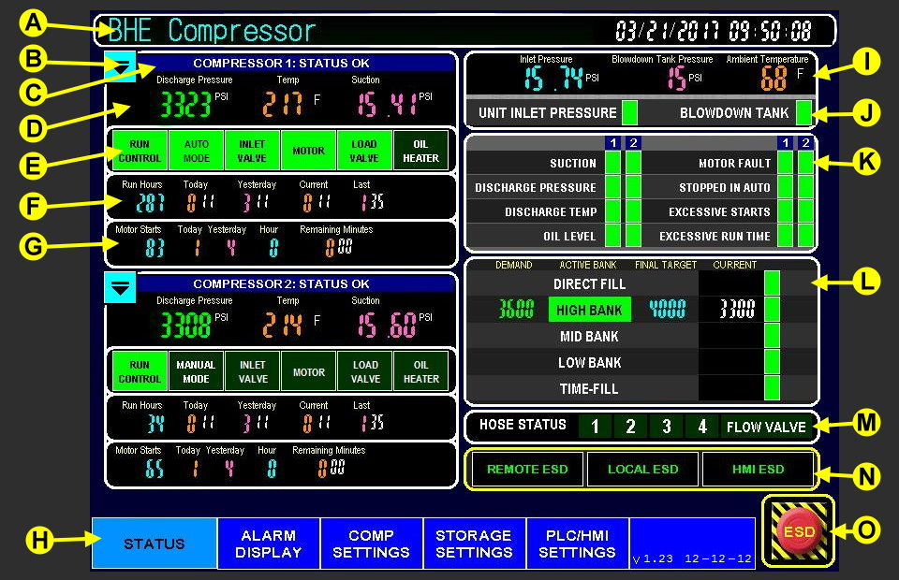(A) Site Name, Defined in the EMAIL section under PLC/HMI SETTINGS.
(B) Individual compressors dropdown pushbutton menu allowing for HMI Starting,
Stopping, and Manual/Auto Mode unit changes.
(C) Individual compressor general health, either STATUS OK or STATUS FAULTED.
(D) Individual compressor Dischage pressure, Discharge Temperature, and Suction
pressure.
(E) Individual compressor operational states of the RUN position switch, Logical
Manual/Auto mode, Inlet valve, Motor starter, Load valve, and Crankcase oil heater.
(F) Individual compressor total RUN HOURS, for today, for yesterday, for current run, and
for the last run.
(G) Individual compressor total MOTOR STARTS, today starts, yesterday starts, and dynamic
start window for the excessive motor starts within an Hour fault and its remaining timer
(This is a logical fault condition to prevent excessive short cycling of the compressor).
(H) Menu Categories.
(I) Inlet pressure, Blowdown tank pressure, and Ambient temperature.
(J) UNIT INLET PRESSURE OK/AL/SD indicator
BLOWDOWN TANK pressure OK/AL/SD indicator
(K) (Analog) SUCTION 1 & 2 OK/AL/SD indicator
(Analog) DISCHARGE PRESSURE 1 & 2 OK/AL/SD indicator
(Analog) DISCHARGE TEMPERATURE 1 & 2 OK/AL/SD indicator
(Digital) OIL LEVEL 1 & 2 OK/SD indicator
(Digital) MOTOR FAULT 1 & 2 OK/SD indicator
(Logical) STOPPED IN AUTO 1 & 2 OK/SD indicator
(Logical) EXCESSIVE STARTS 1 & 2 indicator
(Logical) EXCESSIVE RUN TIME 1 & 2 OK/SD indicator.
(L) DEMAND pressure values, ACTIVE BANK(s) indicator , FINAL TARGET pressure(s), and
CURRENT BANK pressure(s).
(M) HOSE IN USE (1-4) and FLOW VALVE indicators.
(N) ESD Condition indicators.
(O) HMI ESD pushbutton (Logical).

  - Alarm Screen
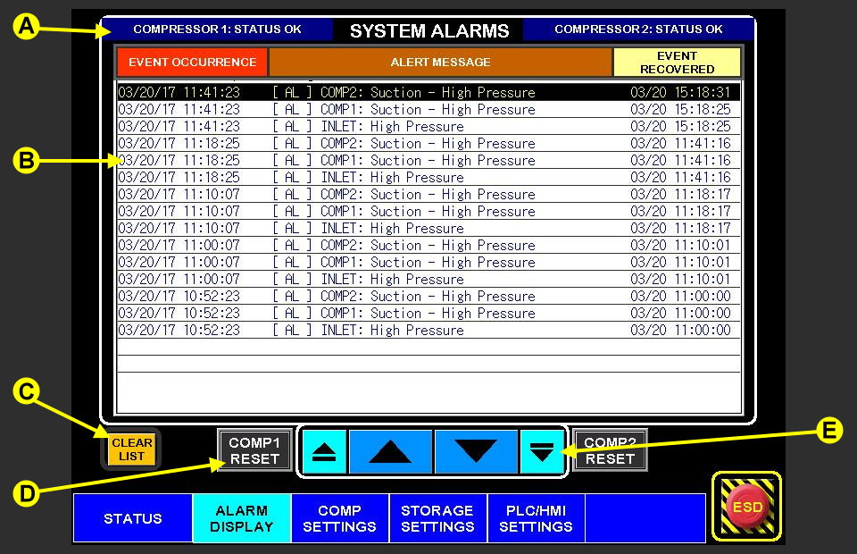
(A) Individual compressor general health, either STATUS OK or STATUS FAULTED.
(B) Event Occurrence: Date and timestamp when the event triggered.
Alert Message: [Type] source: affected
Event Recovered: Date and timestamp when the event was recovered or reset.
(C) Clears the SYSTEM ALARMS list.
(D) COMPRESSOR # reset pushbutton.
(E) Page up, scroll up, scroll down, and page down pushbuttons.

  - Compressor Menu Selection Screen
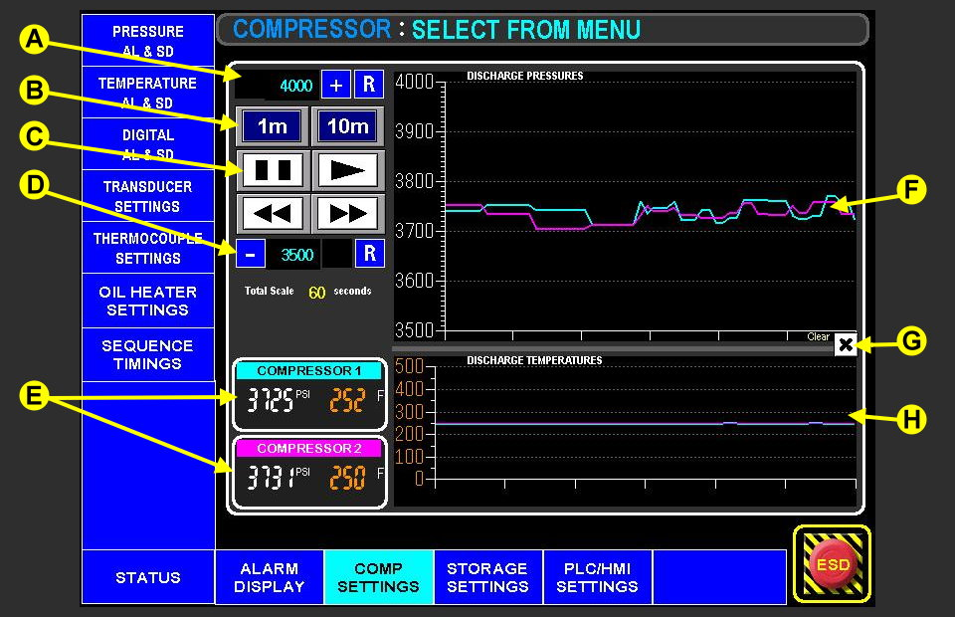
(A) Upper graph display boundary (5000 maximum). ‘R’ button resets to maximum.
(B) Visible data sample duration for both DISCHARGE PRESSURES and DISCHARGE
TEMPERATURES each in their respective line colors. When 1 minute is selected each
segment is 10 seconds. When 10 minute is selected each segment is approximately
100 seconds.
(C) PAUSE, PLAY real-time, scroll BACKWARDS and scroll FORWARD (only while paused).
(D) Lower graph display boundary (0 minimum). ‘R’ button resets to minimum.
(E) Real-time compressor DISCHARGE PRESSURE(s) and DISCHARGE TEMPERATURE(s).
(F) DISCHARGE PRESSURES trending graph with user selectable ranges and scale.
(G) Clear all trending data pushbutton.
(H) DISCHARGE TEMPERATURES trending graph follows user selected durations.

  - Compressor Pressure Alarm and Shutdown Settings
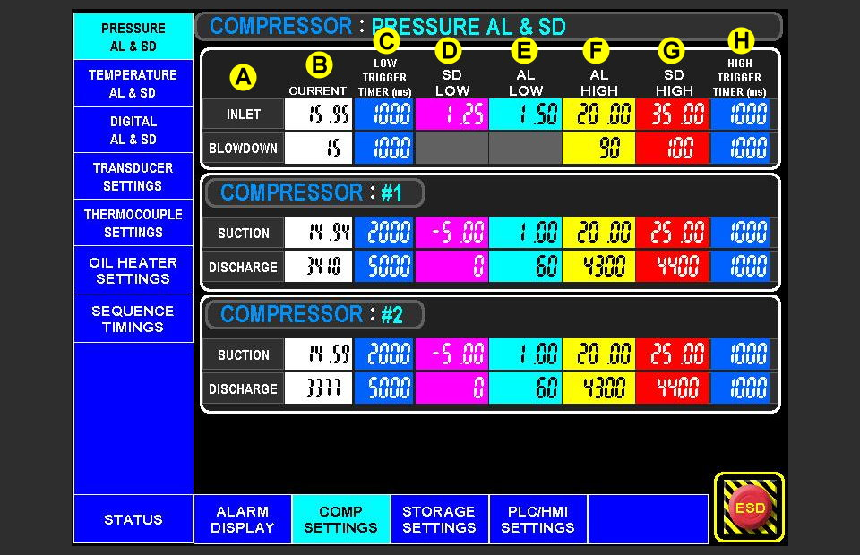
(A) Device name.
(B) A reference display of the current pressure as reported by the plc.
(C) LOW TRIGGER TIMER setting. This timer starts once a LOW condition is in effect. If in
effect for the duration of the timer and the timer expires, then the corresponding LOW
condition alarm (AL) or shutdown (SD) is triggered and the UNIT will respond according
to the related defined sequence.
(D) Pressure condition ‘SD LOW’ threshold that if passed below, will start the LOW TRIGGER
TIMER for said shutdown (SD) condition.
(E) Pressure condition ‘AL LOW’ threshold that if passed below, will start the LOW TRIGGER
TIMER for said alarm (AL) condition.
(F) Pressure condition ‘AL HIGH’ threshold that if exceeded, will start the HIGH TRIGGER
TIMER for said alarm (AL) condition.
(G) Pressure condition ‘SD HIGH’ threshold that if exceeded, will start the HIGH TRIGGER
TIMER for said shutdown (SD) condition.
(H) HIGH TRIGGER TIMER setting. This timer starts once a HIGH condition is in effect. If in
effect for the duration of the timer and the timer expires, then the corresponding HIGH
condition alarm (AL) or shutdown (SD) is triggered and the UNIT will respond according
to the defined sequence.
  - Compressor Temperature Alarm and Shutdown Settings
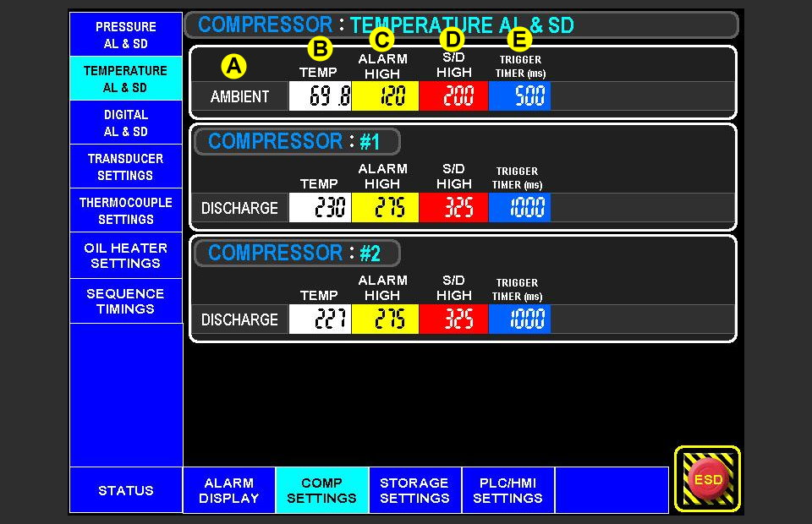
(A) Device name.
(B) A reference display of the current temperature as reported by the thermocouple.
(C) Pressure condition ‘AL HIGH’ threshold that if exceeded, will start the TRIGGER
TIMER for said alarm (AL) condition.
(D) Pressure condition ‘SD HIGH’ threshold that if exceeded, will start the TRIGGER
TIMER for said shutdown (SD) condition.
(E) TRIGGER TIMER setting. This timer duration starts once a condition is in effect. If in
effect for the duration of the timer and the timer expires, then the corresponding HIGH
condition alarm (AL) or shutdown (SD) is triggered and the UNIT will respond
according to the defined sequence.

  - Compressor Digital and Logical Shutdown Settings
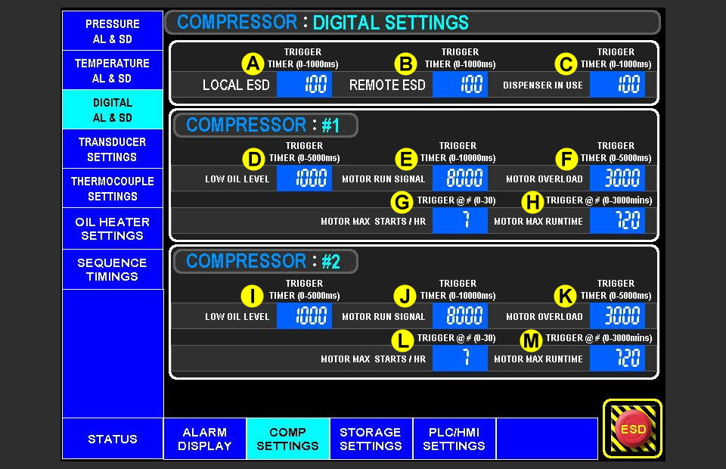
(A) LOCAL ESD: TRIGGER TIMER setting. This timer duration starts once the condition is in
effect. If in effect for the duration of the timer and the timer expires, then the
corresponding shutdown (ESD) is triggered and the UNIT will respond according to the
defined ESD shutdown sequence.
(B) REMOTE ESD: TRIGGER TIMER setting. This timer duration starts once the condition is in
effect. If in effect for the duration of the timer and the timer expires, then the
corresponding shutdown (ESD) is triggered and the UNIT will respond according to the
defined ESD shutdown sequence.
(C) DISPENSER IN USE: TRIGGER TIMER setting. This timer duration starts once a ‘HOSE IN
USE’ signal is received. If in effect past the duration of the timer , the FLOW VALVE will
be Energized (OPEN) to allow flow from storage to the signaling dispenser until ALL
‘HOSE IN USE’ signals have been terminated.
(D,I) Compressor #, LOW OIL LEVEL: TRIGGER TIMER setting. This timer duration starts once
the condition is in effect. If in effect for the duration of the timer and the timer expires,
then the corresponding shutdown (SD) is triggered and the UNIT will respond according
to the defined shutdown sequence.
(E,J) Compressor #, MOTOR RUN SIGNAL: TRIGGER TIMER setting. This timer duration starts
once the motor has been commanded to start. If no MOTOR RUN SIGNAL is returned
and the timer expires, then the corresponding shutdown (SD) is triggered and the UNIT
will respond according to the defined shutdown sequence.
(F,K) Compressor #, MOTOR OVERLOAD: TRIGGER TIMER setting. This timer duration starts
once the MOTOR OVERLOAD signal has been lost. If no MOTOR OVERLOAD signal is
returned and the duration of the timer expires, then the corresponding shutdown (SD) is
triggered and the UNIT will respond according to the defined shutdown sequence.
(G,L) Compressor #, MAX STARTS / HR: TRIGGER EVENT setting. Once the motor starts and no
MAX STARTS timer is in effect, a 60 minute countdown timer starts. Each start while the
timer is active counts toward MAX STARTS. If the MAX STARTS count is exceeded a
shutdown condition for the specific compressor is triggered. Once the countdown timer
expires the starts counter is reset to zero. This is information is displayed on the main
status page in the STARTS section.
(H,M) Compressor #, MOTOR MAX RUNTIME: TRIGGER EVENT setting. During a single
sequence cycle, if the motor is energized longer than the specified time (defined in
minutes) a shutdown event will be triggered for the specific compressor.

  - Compressor Transducer Settings
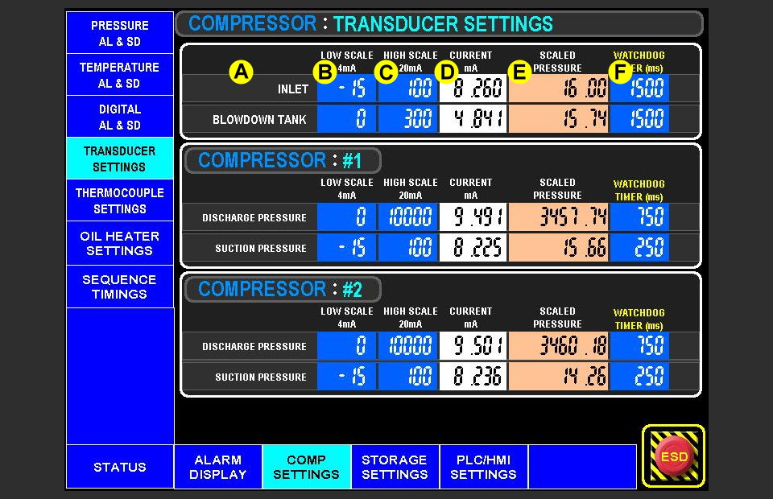
(A) Device name.
(B) Transducer scale LOW value (4ma)
(C) Transducer scale HIGH value (20ma)
(D) A reference display of the transducer current as reported by the plc.
(E) A reference display of the current scaled pressure.
(F) WATCHDOG TIMER setting. This monitors the state of the transducer. This timer starts
once the transducer current is < 3.82ma or > 20.36ma (out of bounds low or high). If the
timer expires, then the corresponding shutdown (SD) condition is triggered and the
UNIT will respond according to the defined sequence.

  - Compressor Thermocouple Settings
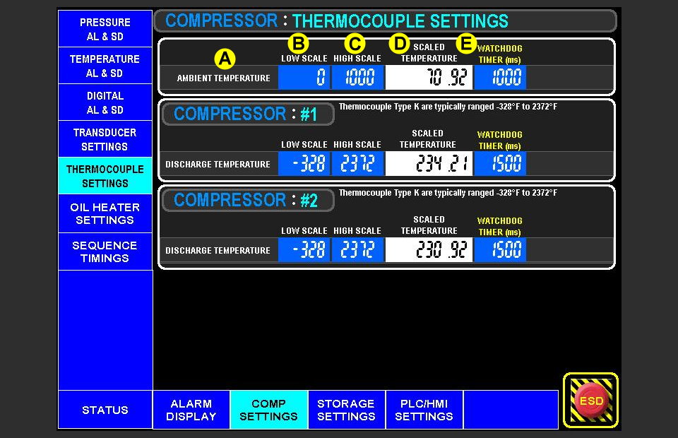
(A) Device name.
(B) Thermocouple scale LOW value.
(C) Thermocouple scale HIGH value
(D) A reference display of the current scaled temperature in degrees Fahrenheit.
(E) WATCHDOG TIMER setting. This monitors the state of the thermocouple. This timer
starts once the thermocouple sensor is out of bounds low or high. If the timer expires,
then the corresponding shutdown (SD) condition is triggered and the UNIT will respond
according to the defined sequence.

  - Compressor Oil Heater Settings
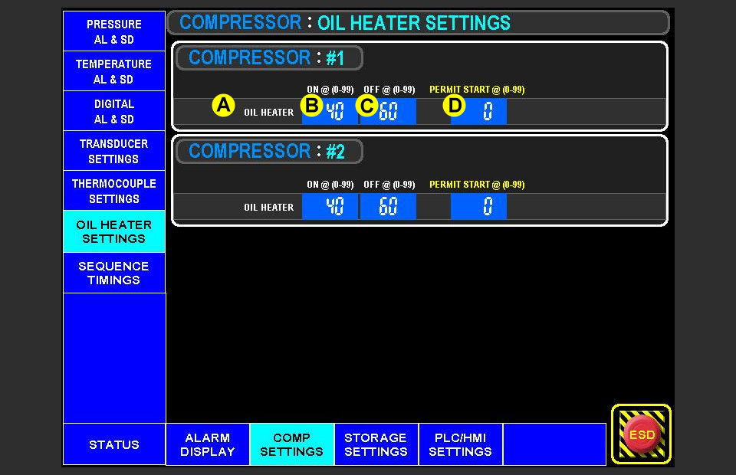
(A) Device name.
(B) Low temperature at which to energize the compressors crankcase oil heater.
(C) High temperature at which to de-energize the compressors crankcase oil heater.
(D) Permit AUTO mode starting when temperature is >= set point ( 0=Disabled).

  - Compressor Sequence Timers
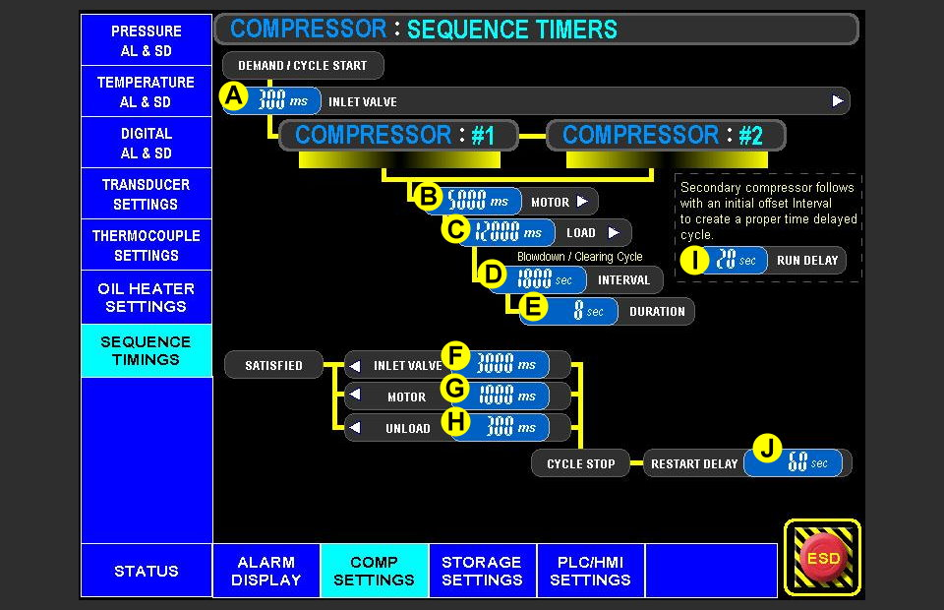
(A) Once a cycle starts, be it from ‘DEMAND’ or manual ‘START’ pushbutton, the ‘INLET’
delay timer is started. When the timer expires the INLET valve is energized (OPEN).
(B) Once the ‘INLET’ valve is energized a ‘MOTOR’ delay timer starts. When the timer
expires the ‘MOTOR’ run is energized (ON).
(C) Once the ‘MOTOR’ run is energized a ‘LOAD’ delay timer starts. When the timer expires
the ‘Blowdown/Clearing cycle’ logic is activated.
(D) Once the ‘Blowdown/Clearing cycle’ logic is active an ‘INTERVAL’ timer is started.
(E) Each time the ‘INTERVAL’ timer is triggered the compressor De-energizes (OPEN) the
‘LOAD’ valve, starts a duration timer, then Re-Energizes (CLOSE) the ‘LOAD’ valve once
the timer expires.
When all storage is brought to a satisfied state, meaning pressures => Final target pressures, the compressor starts three separate ‘NORMAL’ shutdown timers.
(F) When the INLET VALVE timer expires the inlet valve will be De-Energized
(CLOSED).
(G) When the MOTOR run timer expires the motor will be De-Energized (OFF).
(H) When the UNLOAD timer expires the ‘Blowdown/Clearing cycle’ logic is
deactivated and the ‘LOAD’ valve is De-Energized (OPEN).
(I) Once a ‘MOTOR’ is energized for a compressor a delay timer starts. When the timer
expires the second compressor is permitted to start.
(J) When a ‘NORMAL’ shutdown of a compressor (in AUTO mode) takes place a RESTART
timer is established. Once the RESTART timer expires, the compressor is permitted to
START.

  - Storage Main Selection Menu
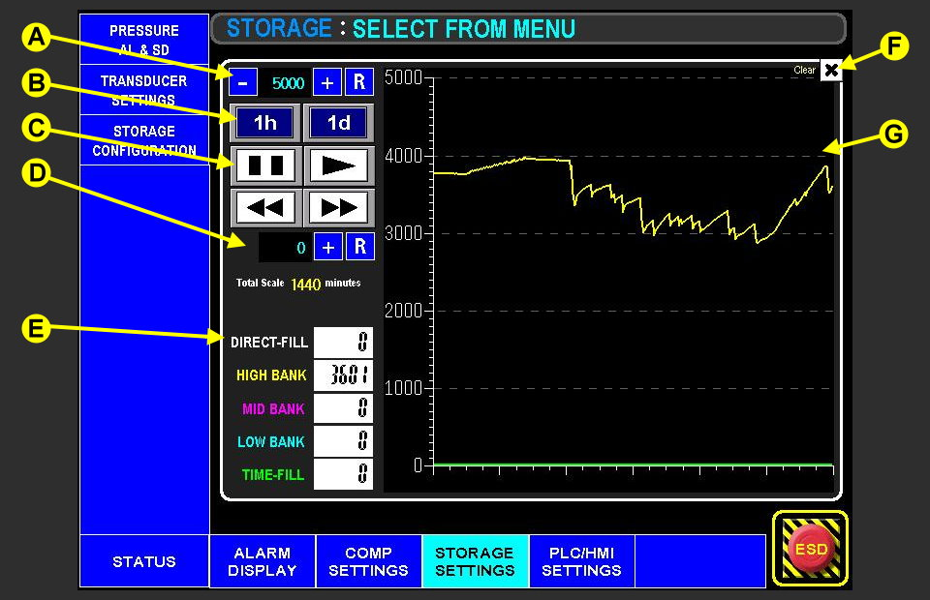
(A) Upper graph display boundary (5000 maximum). ‘R’ button resets to maximum.
(B) Visible data sample duration for STORAGE PRESSURE(s) each in their respective line
colors. When 1h is selected each minor segment is 2.5 minutes. When 1d is
selected each minor segment is approximately 1 hour.
(C) PAUSE, PLAY real-time, scroll BACKWARDS and scroll FORWARD (only while paused).
(D) Lower graph display boundary (0 minimum). ‘R’ button resets to minimum.
(E) Real-time STORAGE PRESSURE(s).
(F) Clear all trending data pushbutton.
(G) STORAGE PRESSURE(s) trending graph with user selectable ranges and scale.

  - Storage Pressure Alarm and Shutdown Settings
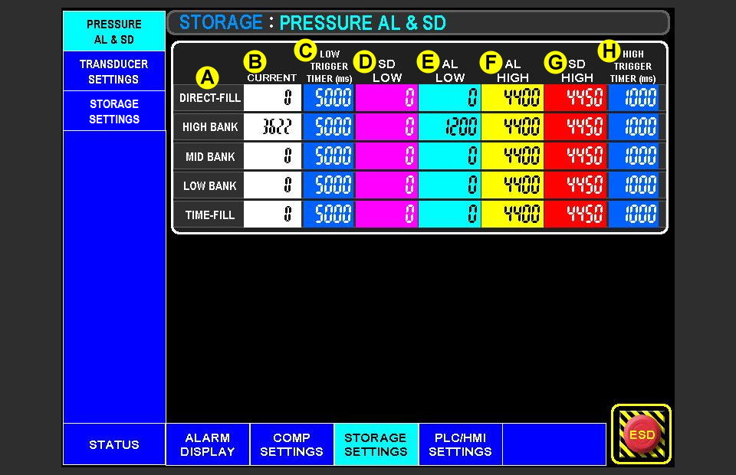
(A) Device name.
(B) A reference display of the current pressure as reported by the plc.
(C) LOW TRIGGER TIMER setting. This timer starts once a LOW condition is in effect. If in
effect for the duration of the timer and the timer expires, then the corresponding LOW
condition alarm (AL) or shutdown (SD) is triggered and the UNIT will respond according
to the related defined sequence.
(D) Pressure condition ‘SD LOW’ threshold that if passed below, will start the LOW TRIGGER
TIMER for said shutdown (SD) condition.
(E) Pressure condition ‘AL LOW’ threshold that if passed below, will start the LOW TRIGGER
TIMER for said alarm (AL) condition.
(F) Pressure condition ‘AL HIGH’ threshold that if exceeded, will start the HIGH TRIGGER
TIMER for said alarm (AL) condition.
(G) Pressure condition ‘SD HIGH’ threshold that if exceeded, will start the HIGH TRIGGER
TIMER for said shutdown (SD) condition.
(H) HIGH TRIGGER TIMER setting. This timer starts once a HIGH condition is in effect. If in
effect for the duration of the timer and the timer expires, then the corresponding HIGH
condition alarm (AL) or shutdown (SD) is triggered and the UNIT will respond according
to the defined sequence.
  - Storage Transducer Settings
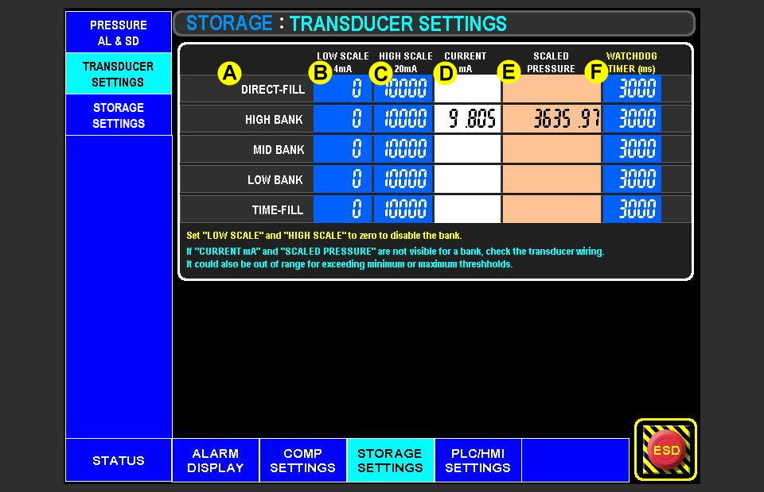
(A) Device name.
(B) Transducer scale LOW value (4ma)
(C) Transducer scale HIGH value (20ma)
(D) A reference display of the transducer current as reported by the plc.
(E) A reference display of the current scaled pressure.
(F) WATCHDOG TIMER setting. This monitors the state of the transducer. This timer starts
once the transducer current is < 3.82ma or > 20.36ma (out of bounds low or high). If the
timer expires, then the corresponding shutdown (SD) condition is triggered and the
UNIT will respond according to the defined sequence.

  - Storage Settings
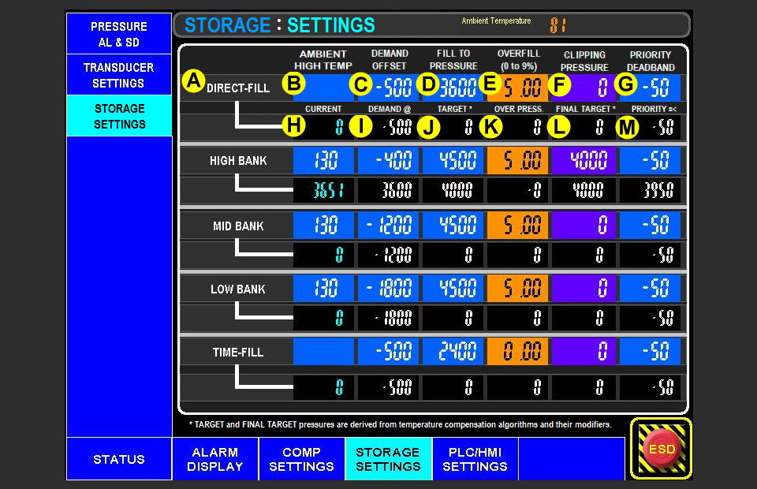
(A) Storage bank name.
(B) Ambient High Temperature: Applies to High, Mid, and Low banks. The ambient
temperature in which the ‘Fill to pressure’ setting is achieved.
(C) Demand Offset: Offset from ‘TARGET’ pressure to determine a demand state.
(D) Fill to Pressure: For High, Mid, and Low banks see temperature compensation in
section 13.2. For Direct-fill and Time-fill see temperature compensation in section 13.1
(E) Overfill %: Percentage of ‘TARGET’ pressure to ‘OVER-FILL’.
(F) Clipping Pressure: No pressure target pressure shall rise above this setting regardless of
temperature compensation.
(G) Priority Deadband: Offset to decide at what pressure a bank is given priority/re-
prioritization.
(H) A reference display of the current scaled pressure.
(I) Demand @: The pressure in which ‘DEMAND’ calls for a UNIT start.
(J) Target: See section 13 Temperature Compensation.
(K) Over Pressure: The amount of pressure added to ‘TARGET’ pressure to formulate ‘FINAL
TARGET’ pressure. ‘CLIPPING’ pressure will reduce this amount if it causes ‘FINAL
TARGET’ pressure to exceed ‘CLIPPING’ pressure.
(L) Final Target: Pressure in which the banks ‘DEMAND’ is considered ‘SATISFIED’.
(M) Priority =<: When the bank is equal to or less than this pressure, it is in consideration for
prioritization following the guidelines set forth in section 10.4.

  - PLC / HMI Main Selection Menu
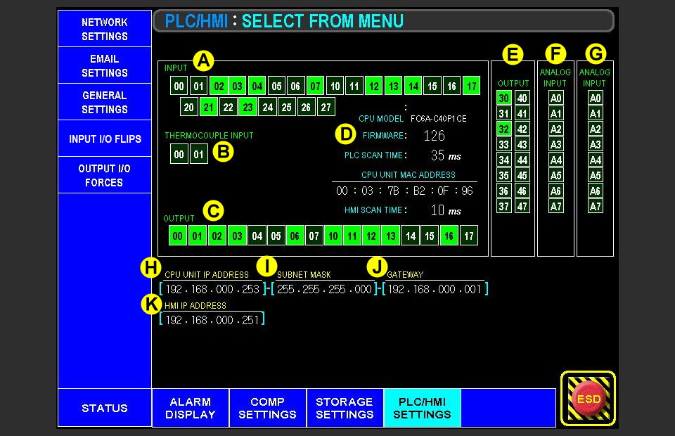
(A) Input Status.
(B) Thermocouple fault status.
(C) Output Status.
(D) PLC / HMI CPU Information.
(E) Module Output Status.
(F,G) Analog fault status.
(H) PLC IP address, (I) PLC Subnet mask, (J) PLC gateway IP.
(K) HMI IP address.

  - PLC / HMI Network Settings
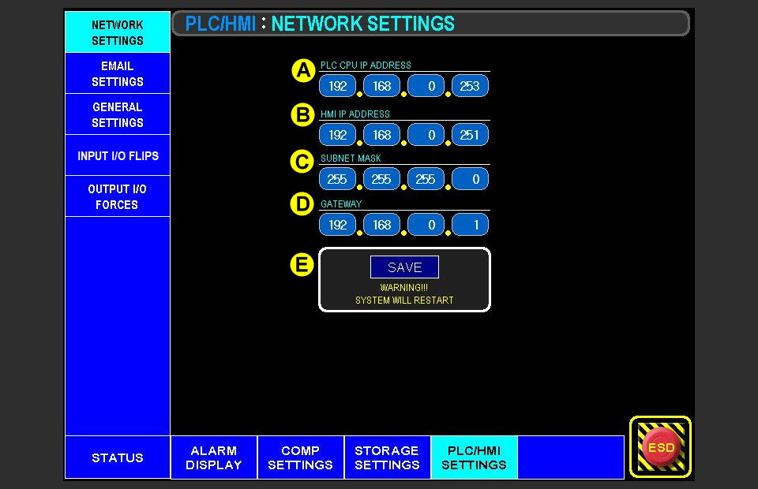
(A) PLC CPU IP address.
(B) HMI Touch Display IP address.
(C) Subnet mask for both, (D) Gateway address for both.
(E) Commit changes and restart the PLC and HMI.

  - PLC/HMI Email Settings
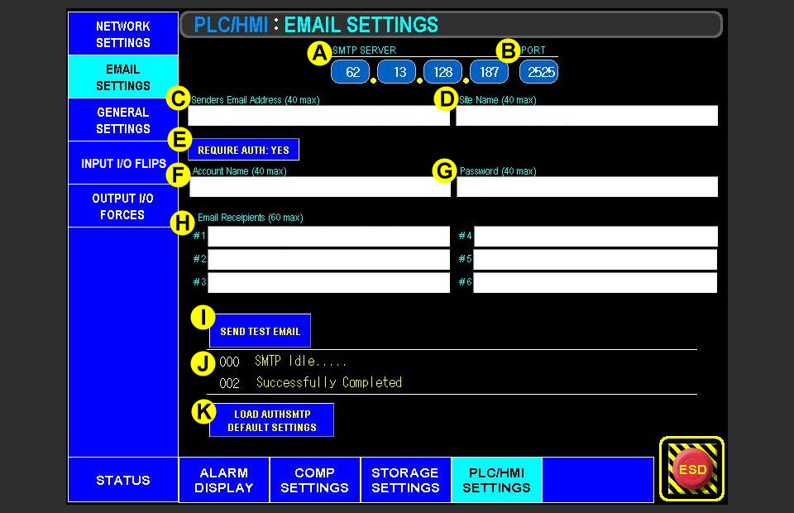
(A) SMTP Servers IP address.
(B) SMTP Servers port number.
(C) Senders Email Address. Must be a fully qualified email address.
(D) Site Name, this is displayed in the ‘From’ field in the email as well a displayed on the
main status page.
(E) Setting for if the SMTP server requires TLS/SSL.
(F) Email account login name.
(G) Email account password.
(H) Email recipients list, only 1 per.
(I) Once configured this will allow you to send out a test email to the recipients list.
(J) Test email sending status and error code if failure.
(K) Preloaded Authsmtp service defaults.

  - PLC/HMI General Settings
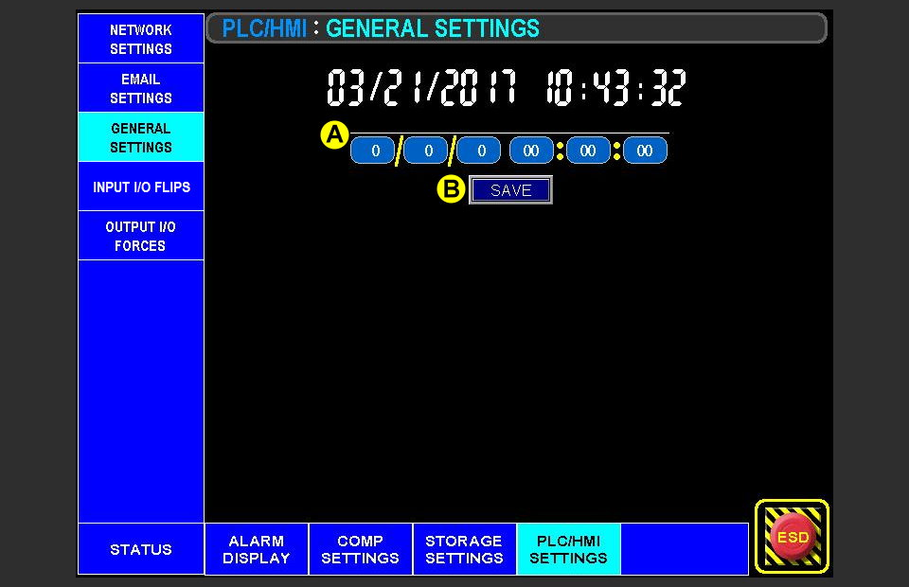
(A) HMI Date and Time setting: MM/DD/YYYY HH:MM:SS
(B) Commit changes

  - PLC/HMI Input IO State Settings
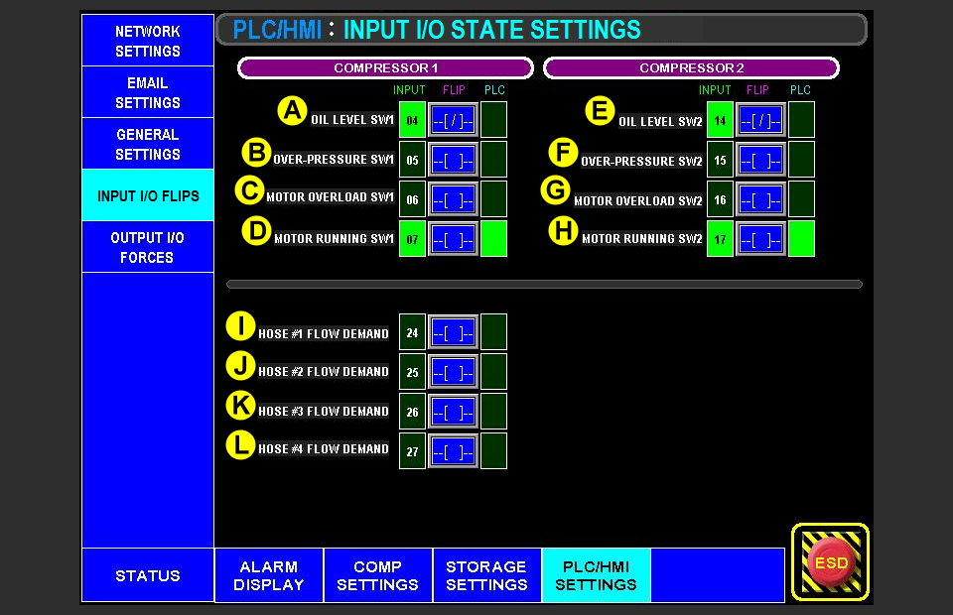
(A) OIL LEVEL SW1.
(B) OVER-PRESSURE SW1 (Optional Pressure Switch).
(C) MOTOR OVERLOAD SW1 (Contactor Overload AUX contacts).
(D) MOTOR RUNNING SW1 (Contactor AUX contacts or Soft Starter dry contacts).
(E) OIL LEVEL SW2.
(F) OVER-PRESSURE SW2 (Optional Pressure Switch).
(G) MOTOR OVERLOAD SW2 (Contactor Overload AUX contacts).
(H) MOTOR RUNNING SW2 (Contactor AUX contacts or Soft Starter dry contacts).
(I,J,K,L) ‘HOSE IN USE’ Signals (Flow demand).

  - PLC/HMI Output IO Forces
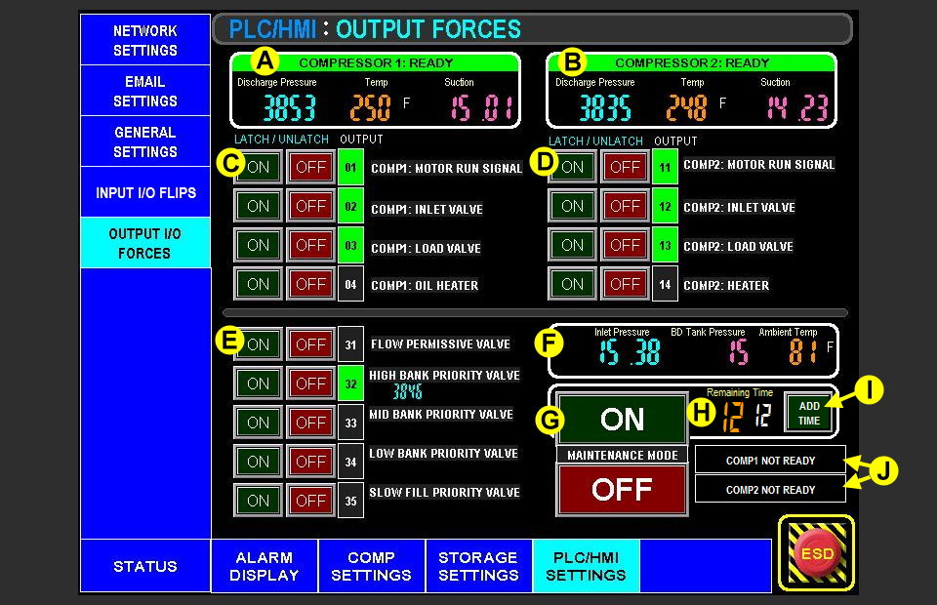
(A) Compressor 1 Status, Discharge Pressure, Discharge Temperature, and Suction Pressure.
(B) Compressor 2 Status, Discharge Pressure, Discharge Temperature, and Suction Pressure.
Sections (C, D, and E) are only active if (G) MAINTENANCE MODE is ‘ON’ and (H) REMAINING TIME is greater than zero.
(C) Compressor 1 LATCH/UNLATCH pushbuttons for MOTOR RUN SIGNAL, INLET VALVE,
LOAD VALVE, and OIL HEATER.
(D) Compressor 2 LATCH/UNLATCH pushbuttons for MOTOR RUN SIGNAL, INLET VALVE,
LOAD VALVE, and OIL HEATER.
(E) Storage LATCH/UNLATCH pushbuttons for FLOW VALVE, HIGH BANK VALVE, MID BANK
VALVE, LOW BANK VALVE, and SLOW FILL VALVE.
(F) UNIT Inlet pressure, BLOWDOWN tank pressure, and AMBIENT TEMPERATURE.
(G) Enable (ON) MAINTENANCE MODE or Disable (OFF) MAINTENANCE MODE.
(H) Remaining Time until MAINTENANCE MODE is automatically disabled (OFF).
(I) Add 10 minutes to the remaining time (max 60 minutes).
(J) Compressor state to permit MAINTENANCE MODE
(1) Panel selector switch must be in the ‘RUN’ position.
(2) Operational mode must be in ‘MANUAL’ mode.
Note: ALL SHUTDOWNS except LOW STORAGE PRESSURES are in effect.
There is NO sequencing while in MAINTENANCE MODE proceeding
with extreme caution is advised.
Unsafe use can cause damage to equipment and/or operator.

- WEB VIEWER ACCESS
Using a web browser connect to http://192.168.0.251 (this is the factory default)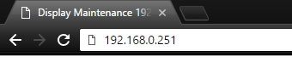
You will be prompted for login information.
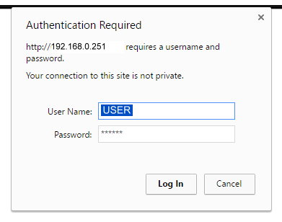
Enter USER for user name and 4321 for the password. Then click ‘Log In’
Once fully loaded you should see the default System Information Screen.
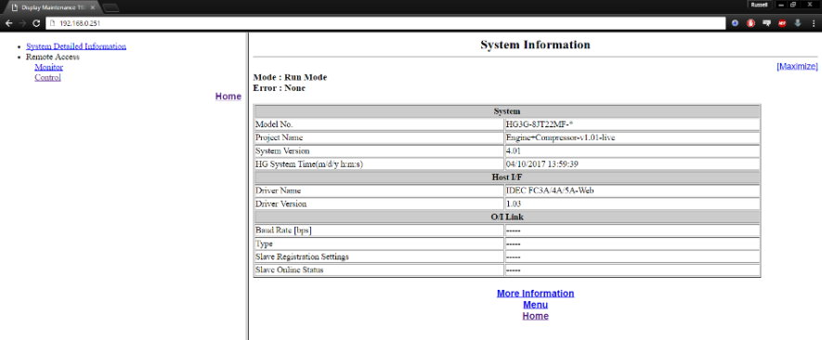
To just monitor the UNIT Select ‘Monitor’ to fully control the UNIT Select ‘Control’
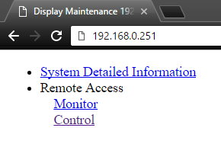
Once the ‘REMOTE CONTROL’ panel is loaded you can select ‘Maximize’ to open the HMI in a standalone tab or screen (It is recommended that you bookmark this page for easy access).
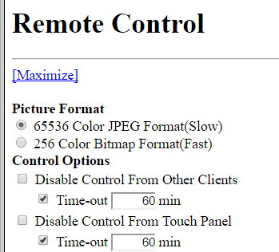
You can select a ‘Picture Format’ to optimize your latency with the HMI. ‘65536 Color’ will look much better but load slowly on a poor or slow connection.
Control options allow you disable control from other connections and Disable the ‘LOCAL’ touch panel input for the designated time-out.

- IO PLC Reference
  - OUTPUT IO List
PLC OUTPUT CHANNEL | DESCRIPTION
Q00 | COMPRESSOR 1: SHUTDOWN STATE STATUS (OK=ON, FAULTED=OFF)
Q01 | COMPRESSOR 1: MOTOR RUN SIGNAL
Q02 | COMPRESSOR 1: INLET VALVE
Q03 | COMPRESSOR 1: BLOWDOWN/LOAD VALVE
Q04 | COMPRESSOR 1: OIL HEATER
Q05 | COMPRESSOR 1: RED LED INDICATOR
Q06 | COMPRESSOR 1: GREEN LED INDICATOR
Q07 | Unused
Q10 | COMPRESSOR 2: SHUTDOWN STATE STATUS (OK=ON, FAULTED=OFF)
Q11 | COMPRESSOR 2: MOTOR STARTER
Q12 | COMPRESSOR 2: INLET VALVE
Q13 | COMPRESSOR 2: BLOWDOWN/LOAD VALVE
Q14 | COMPRESSOR 2: OIL HEATER
Q15 | COMPRESSOR 2: RED LED INDICATOR
Q16 | COMPRESSOR 2: GREEN LED INDICATOR
Q17 | Unused
OUTPUT MODULE CHANNEL | DESCRIPTION
Q0 | GLOBAL: ESD LOOP PERMISSIVE (ZERO VOLTAGE COMPLIANCY)
Q1 | GLOBAL: FLOW PERMISSIVE VALVE
Q2 | GLOBAL: HIGH BANK STORAGE VALVE
Q3 | GLOBAL: MID BANK STORAGE VALVE
Q4 | GLOBAL: LOW BANK STORAGE VALVE
Q5 | GLOBAL: SLOW FILL STORAGE VALVE

17.2. INPUT IO List
PLC INPUT CHANNEL | DESCRIPTION
I00 | COMPRESSOR 1: SELECTOR SWITCH ‘RESET’
I01 | COMPRESSOR 1: START PUSHBUTTON
I02 | COMPRESSOR 1: STOP PUSHBUTTON
I03 | COMPRESSOR 1: SELECTOR SWITCH ‘RUN’
I04 | COMPRESSOR 1: OIL LEVEL FLOAT SWITCH
I05 | COMPRESSOR 1: OVERPRESSURE SWITCH
I06 | COMPRESSOR 1: MOTOR OVERLOAD SWITCH
I07 | COMPRESSOR 1: MOTOR RUN STATUS SWITCH
I10 | COMPRESSOR 2: SELECTOR SWITCH ‘RESET’
I11 | COMPRESSOR 2: START PUSHBUTTON
I12 | COMPRESSOR 2: STOP PUSHBUTTON
I13 | COMPRESSOR 2: SELECTOR SWITCH ‘RUN’
I14 | COMPRESSOR 2: OIL LEVEL FLOAT SWITCH
I15 | COMPRESSOR 2: OVERPRESSURE SWITCH
I16 | COMPRESSOR 2: MOTOR OVERLOAD SWITCH
I17 | COMPRESSOR 2: MOTOR RUN STATUS SWITCH
I20 | Unused
I21 | GLOBAL: REMOTE EMERGENCY SHUTDOWN (FROM RELAY)
I22 | GLOBAL: EXTERNAL EMERGENCY SHUTDOWN (FROM RELAY)
I23 | GLOBAL: LOCAL EMERGENCY SHUTDOWN PUSHBUTTON
I24 | GLOBAL: HANDLE IN USE (1)
I25 | GLOBAL: HANDLE IN USE (2)
I26 | GLOBAL: HANDLE IN USE (3)
27 | GLOBAL: HANDLE IN USE (4)

17.3. ANALOG IO List
ANALOG MODULE 1 CHANNEL | DESCRIPTION
A00 | TRANSDUCER – GLOBAL: INLET PRESSURE
A01 | TRANSDUCER – GLOBAL: BLOWDOWN TANK PRESSURE
A02 | TRANSDUCER – COMPRESSOR 1: SUCTION PRESSURE
A03 | TRANSDUCER – COMPRESSOR 2: SUCTION PRESSURE
A04 | TRANSDUCER – COMPRESSOR 1: DISCHARGE PRESSURE
A05 | TRANSDUCER – COMPRESSOR 2: DISCHARGE PRESSURE
A06 | Unused
A07 | GLOBAL: AMBIENT TEMPERATURE PROBE
ANALOG MODULE 2  CHANNEL | DESCRIPTION
A00 (A10) | TRANSDUCER – GLOBAL: DIRECT-FILL
A01 (A11) | TRANSDUCER - GLOBAL: HIGH-BANK
A02 (A12) | TRANSDUCER - GLOBAL: MID-BANK
A03 (A13) | TRANSDUCER - GLOBAL: LOW-BANK
A04 (A14) | TRANSDUCER - GLOBAL: TIME-FILL
A05 (A15) | Unused
A06 (A16) | Unused
A07 (A17) | Unused
THEROCOUPLE ANALOG MODULE 1 | DESCRIPTION
TC00 | THERMOCOUPLE – COMPRESSOR 1: DISCHARGE TEMPERATURE
TC01 | THERMOCOUPLE – COMPRESSOR 2: DISCHARGE TEMPERATURE

TECHNICIANS NOTES:
# | ANNUNCIATION | DEVICE | TYPE | RANGE | FACTORY | SETPOINT
 |  |  | 4-20ma
SD | INLET: High Pressure |  |  |  | 35
SD | INLET: Low Pressure |  |  |  | 10
AL | INLET: High Pressure |  |  |  | 30
AL | INLET: Low Pressure |  |  |  | 5
 |  |  | 4-20ma
SD | BLOWDOWN: High Pressure |  |  |  | 275
AL | BLOWDOWN: High Pressure |  |  |  | 250
 |  |  | 4-20ma
SD | COMP1: Suction - High Pressure |  |  |  | 25
SD | COMP1: Suction - Low Pressure |  |  |  | -5
AL | COMP1: Suction - High Pressure |  |  |  | 20
AL | COMP1: Suction - Low Pressure |  |  |  | 0
 |  |  | 4-20ma
SD | COMP2: Suction - High Pressure |  |  |  | 25
SD | COMP2: Suction - Low Pressure |  |  |  | -5
AL | COMP2: Suction - High Pressure |  |  |  | 20
AL | COMP2: Suction - Low Pressure |  |  |  | 0
 |  |  | 4-20ma
SD | COMP1: Discharge - High Pressure |  |  |  | 4400
SD | COMP1: Discharge - Low Pressure |  |  |  | 0
AL | COMP1: Discharge - High Pressure |  |  |  | 4350
AL | COMP1: Discharge - Low Pressure |  |  |  | 0
 |  |  | 4-20ma
SD | COMP2: Discharge - High Pressure |  |  |  | 4400
SD | COMP2: Discharge - Low Pressure |  |  |  | 0
AL | COMP2: Discharge - High Pressure |  |  |  | 4350
AL | COMP2: Discharge - Low Pressure |  |  |  | 0
 |  | K-TYPE | Thermo-couple | -328 to 2372°F
SD | COMP1: Discharge - High Temperature |  |  |  | 275
AL | COMP1: Discharge - High Temperature |  |  |  | 250
 |  | K-TYPE | Thermo-couple | -328 to 2372°F
SD | COMP2: Discharge - High Temperature |  |  |  | 275
AL | COMP2: Discharge - High Temperature |  |  |  | 250
 |  | TGT-TP | 0-10v | 0-1000 °F
AL | AMBIENT TEMPERATURE: High Temperature |  |  |  | 150
 |  |  | 4-20ma
SD | STORAGE: Direct Fill - High Pressure |  |  |  | 4450
SD | STORAGE: Direct Fill - Low Pressure |  |  |  | 0
AL | STORAGE: Direct Fill - High Pressure |  |  |  | 4375
AL | STORAGE: Direct Fill - Low Pressure |  |  |  | 0
 |  |  | 4-20ma
SD | STORAGE: High Bank - High Pressure |  |  |  | 4450
SD | STORAGE: High Bank - Low Pressure |  |  |  | 0
AL | STORAGE: High Bank - High Pressure |  |  |  | 4375
AL | STORAGE: High Bank - Low Pressure |  |  |  | 0
 |  |  | 4-20ma
SD | STORAGE: Mid Bank - High Pressure |  |  |  | 4450
SD | STORAGE: Mid Bank - Low Pressure |  |  |  | 0
AL | STORAGE: Mid Bank - High Pressure |  |  |  | 4375
AL | STORAGE: Mid Bank - Low Pressure |  |  |  | 0
 |  |  | 4-20ma
SD | STORAGE: Low Bank - High Pressure |  |  |  | 4450
SD | STORAGE: Low Bank - Low Pressure |  |  |  | 0
AL | STORAGE: Low Bank - High Pressure |  |  |  | 4375
AL | STORAGE: Low Bank - Low Pressure |  |  |  | 0
 |  |  | 4-20ma
SD | STORAGE: Time Fill - High Pressure |  |  |  | 4200
SD | STORAGE: Time Fill - Low Pressure |  |  |  | 0
AL | STORAGE: Time Fill - High Pressure |  |  |  | 4100
AL | STORAGE: Time Fill - Low Pressure |  |  |  | 0

Page intentionally left blank

Page intentionally left blank

Page intentionally left blank

Page intentionally left blank

Page intentionally left blank

